PROJECT GUIDLINES:-  
*  Those columns that are likely to have a large number of nulls,  
   its recommended that preferably they should be specified at the   
   end of the table structure, to conserve on HD space.  
  
*  All the insert statement should be in this format:-  
     
   insert into table_name(col1, col2, col3, ....)  
   values(val1, val2, val3,.....);  
  
*  its recommended that you should always use  
   double quotes, the select statement becomes more Readable  
  
*  Make multi user project  
*  Have at least one Indian language.

* Have 6 extra columns in every table
* Username, date and time when the row was inserted
* Username, date and time when the row was updated

User(), sysdate(), now()

* Create indexes for the select statements
* Use the extension columns in every table
* Every table should have a primary key
* Entire application should be made on view

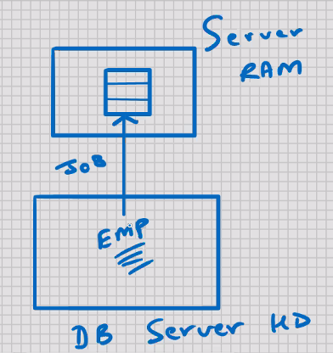

* Whenever you use DISTINCT sorting takes place internally int the Server RAM
* If you have large number of rows in the table , this SELECT statement will be slow.

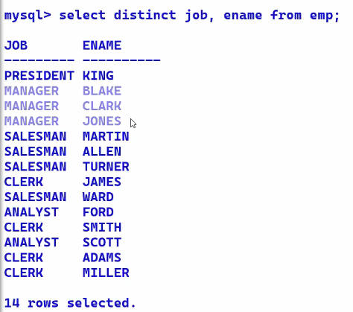

🡪Select distinct job, ename from emp;

* DISTINCT will work on combination of all the columns that are present in SELECT statement

(*) (ERROR)

🡪 select (distinct job), ename from emp;

🡪select deptno, job, ename, sal, hiredate from emp;

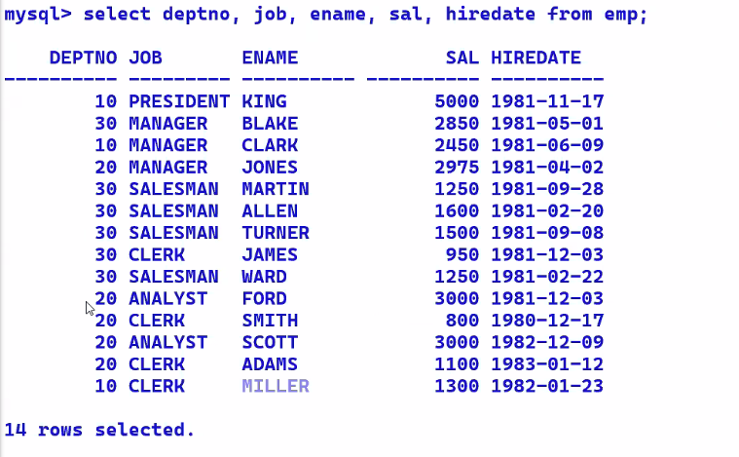

* In a DBMS, data is stored inside a file,
* Inside a file, rows are stored sequentially
* In DBMS; there is a concept of row numbering
* In RDBMS, table is not a file; Every row is a file
* In RDBMS, rows of the table are not stored sequentially; they are not stored in any specific order.
* Rows of the table are scattered (fragmented) all over the DB Server HD.
* The reason why RDBMS does this is to speed up the INSERT statement.
* In a multi-user environment, when multiple users are inserting rows in the same table simultaneously, if MySQL were to store the rows sequentially, then the INSERT operations would be very slow.
* When you INSERT a table, wherever MySQL finds the free space in the DB server HD, it will store the row there.
* When you SELECT from a table, the searching is sequential.
* When you SELECT from a table, the order of rows in the output depends on the row address; it will always be in ascending order of row address
* Once you INSERT a row, the row address is constant
* When you UPDATE a row, if the row length is increasing and the free space is not available, then the entire row is moved to some other address on the DB server HD
* Later when you SELECT from the table, you may see that row at some other location
* It’s only in the case of VARCHAR that the row length may increase or decrease
* Hence it is not possible to see the first ‘N’ rows of a table, or the last ‘N’ rows of a table
* This is common on all RDBMS
* There is a system table which stores all the table names and their respective row addresses.
* When you SELECT from a table, MySQL will not search the entire DB server HD; rather it will go to that system table, and retrieve the rows of the selected table accordingly.

MYSQL – SQL – ORDER BY clause 🡪

* Used for sorting
* Used for presentation purposes / reporting purposes
* Select deptno, job, ename, sal, hiredate, from emp

order by ename; 🡪 by default this will be in ascending order

* Select deptno, job, ename, sal, hiredate, from emp

order by ename desc; 🡪 in descending order

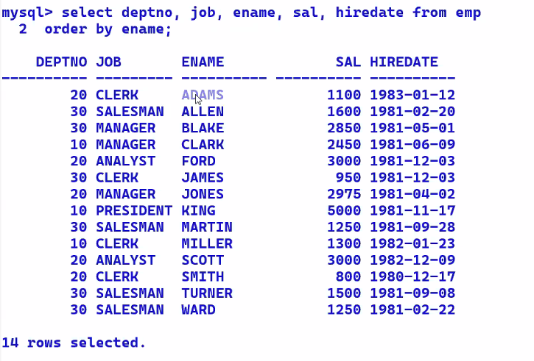

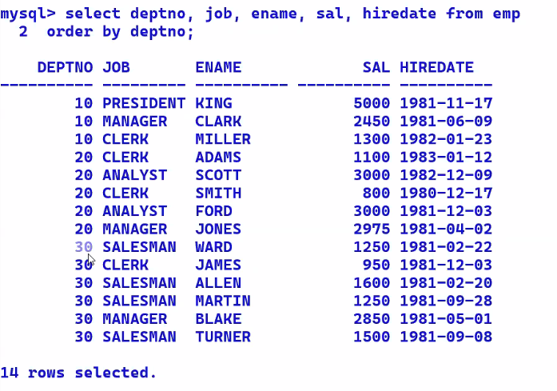

* Select deptno, job, ename, sal, hiredate, from emp

order by deptno, job;

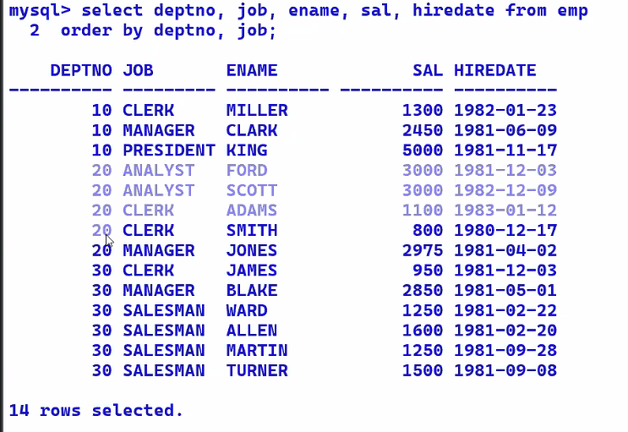

* Select deptno, job, ename, sal, hiredate, from emp

order by deptno desc, job desc;

Note :- select ……………..

order by country, state, city;

* + No upper limit on the number of columns in ORDER BY clause
  + If you have a large number of rows in the table, and a large number of columns in ORDER BY clause, then the SELECT statement will be slow, because that much sorting has to take place in Server RAM

* Select deptno, job, ename, sal, hiredate from emp

Where deptno = 10

Order by ename;

* + SELECT statement executes from top to bottom and left to right
  + WHERE clause has to specified BEFORE the ORDER BY clause
  + WHERE clause is used for searching; Searching takes place in the DB Server HD
  + WHERE clause is used to restrict the rows
  + WHERE clause is used to retrieve the rows from DB Server HD to Server RAM
  + ORDER BY clause sorting takes place in Server RAM
  + ORDER BY clause is the LAST clause in SELECT statement
* Select ename , sal*12 from emp;

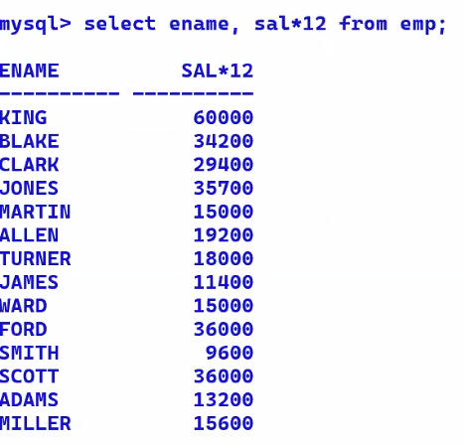

* Select ename , sal*12 from emp

Order by sal*12;

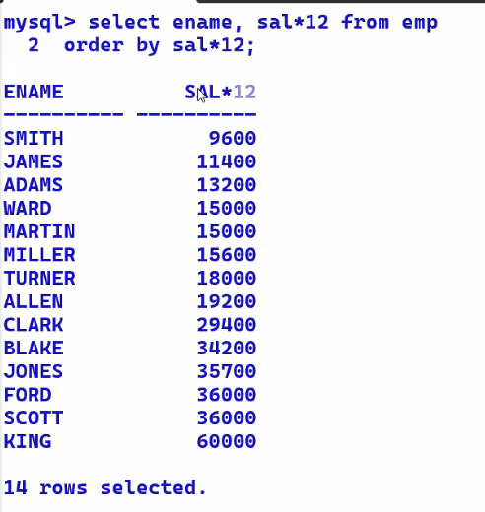

* Select ename , sal*12 annual from emp

Order by annual;

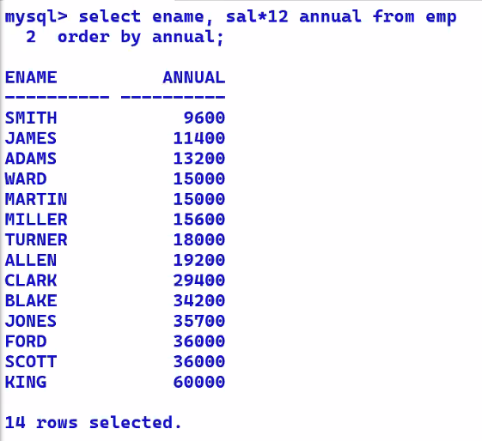

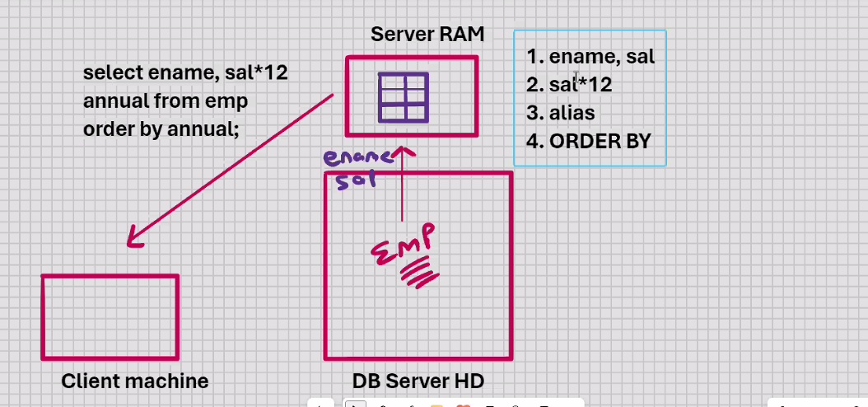

* Select ename , sal*12 “Annual Salary” from emp

Order by “Annual Salary”;

Easy way to do the above query

* Select ename , sal*12 “Annual Salary” from emp

Order by 2; 🡪 2 column

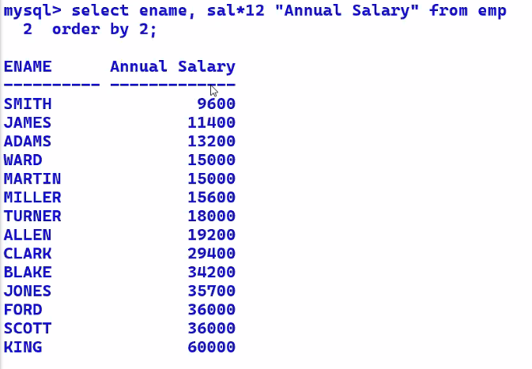

* Select * from emp

Order by 1;

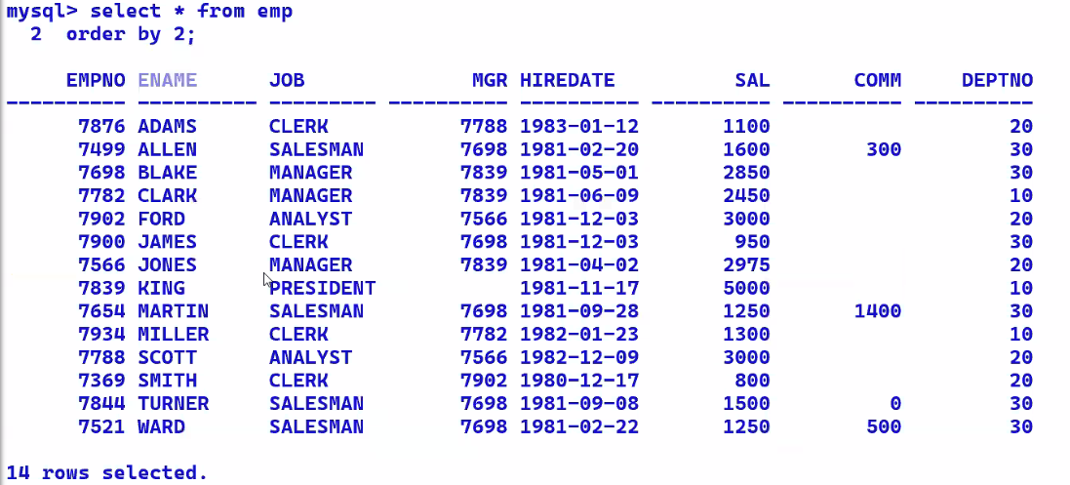

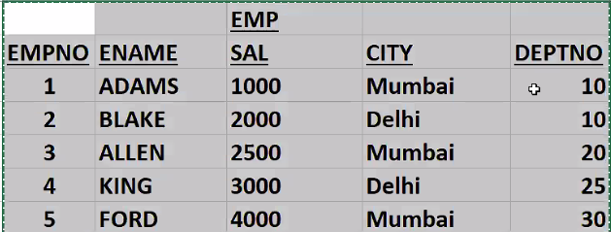

ENAME VARCHAR(20)

* select * from emp

where ename > ‘A’ and ename <’B’;

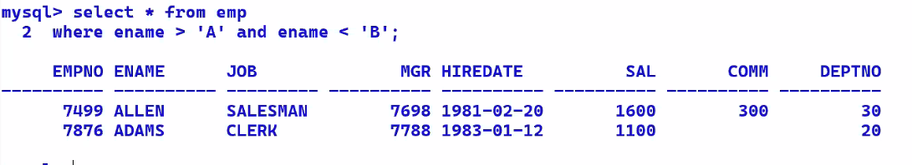

* Blank – padded comparison semantics:-
  + When you compare 2 strings of different lengths, the shorter of the 2 strings is temporarily padded with blank spaces **left at 4:43**
* select * from emp

where ename >= ‘A’ and ename <’B’;

* select * from emp

where ename >= ‘A’ and ename <’C’;

MYSQL – SQL – Special Operators(Like) 🡪

Wildcards (used for pattern matching)

% any character and any number of characters

_ any 1 character

* select * from emp

where ename like ‘A%’; 🡪 starting with A

* select * from emp

where ename like ‘%A’; 🡪 ending with A

* select * from emp

where ename like ‘%A%’; 🡪 or A at any position in between

* select * from emp

where ename not like ‘A%’; 🡪 not starting with A

* select * from emp

where ename like ‘_ _A%’; 🡪 names with 3rd letter with A

* select * from emp

where ename like ‘_ _ _ _’; 🡪 names with 4 letter with

* select * from emp

where ename like ‘_ I_ _’; 🡪 names with 4 letters with I as second character --KING

* select * from emp

where ename like ‘_ I%’; 🡪 names with 2nd letters with I -- CINDERELLA , KING

Special Operators(Between) 🡪

* select * from emp

where sal >= 2000 and sal <= 3000;

* select * from emp

where sal between 2000 and 3000; 🡨 inclusive

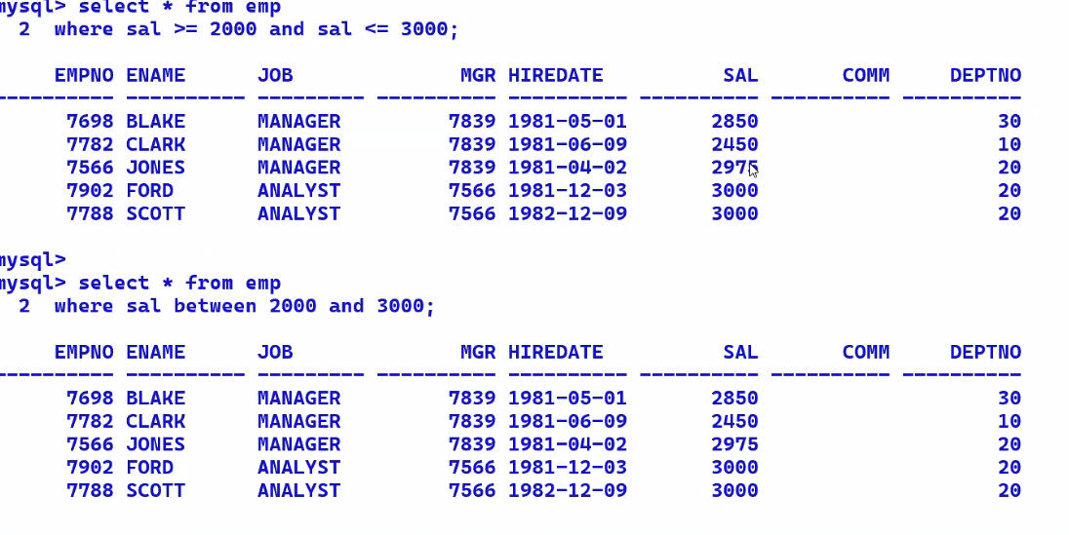

* select * from emp

where sal not between 2000 and 3000; 🡨 exclusive

* select * from emp

where hiredate >= ‘2023-01-01’ and hiredate <= ‘2023-12-31’;

* select * from emp

where hiredate between ‘2023-01-01’ and ‘2023-12-31’;

* select * from emp

where ename >= ‘A’ and ename <= ‘F’;

* select * from emp

where ename between ‘A’ and ‘F’;

* select * from emp

where deptno = 10 or deptno = 20 or deptno = 30; 🡨 MOST POWERFULL

Special Operators(Any) 🡪

* select * from emp

where deptno = any(10, 20 , 30); can be checked for != , > , < , >= , <= 🡨 FASTER

Special Operators(In) 🡪

* select * from emp

where deptno in(10, 20 , 30); can be checked for not in only 🡨 FASTEST

* + ANY 🡪 logical OR
  + IN 🡪 logical OR
  + Any and In both are similar
* ANY operator is overloaded (operator overloading)
* IN operator is faster than ANY operator
* ANY operator is more powerful than IN operator
* With the IN operator, you can only check for IN and NOT IN
* With the ANY operator, you can check for = ANY, !=ANY , >ANY, >=ANY, <ANY, <=ANY
* If you want to check for equality or inequality, then use the IN operator
* If you want to check for > , >= , <, or <= , then use the ANY operator
* If your requirements are more complex, then use the relational and logical operators.
* IN operator is supported by MySQL
* ANY operator is supported by MySQL only when it is used with sub-query
* Select * from emp

city in(‘Mumbai’, ‘Delhi’);

UPDATE

* Update emp

Set sal = 10000

Where empno = 1;

* Update emp

Set sal = sal + sal*0.4 🡨 make the sal increase the sal by 40%

Where empno = 1;

* Update emp

Set sal = 10000 , city = ‘Pune’

Where city = ‘Mumbai’;

* Update emp

Set sal = 10000 , city = ‘Pune’

Where empno = 1;

* You can UPDATE multiple rows and multiple columns simultaneously, but you can UPDATE only 1 table in a single command
* If you want to update 2 or more tables, then a separate UPDATE command is needed for each table
* Update emp

Set sal = 10000

Where empno = 1; // we can change where condition as per our need

* Update emp

Set sal = 10000 ; 🡪 updates the entire column of sal to 10000

DELETE

* Delete from emp

Where empno = 1;

* Delete from emp

Where city = ‘Mumbai’ ;

* Delete from emp; 🡨 empties the table but structure remains

DROP

* Drop table emp; 🡪 whole table will be deleted permanently
* Drop table emp, dept; 🡪 to delete multiple tables
* You cannot have a WHERE clause with DROP table because DROP table is a DDL command.

TRANSACTION PROCESSING 🡪

* Roll back will undo all the DML changes since the last committed state
* What is committed cannot be Rolled back
* Rollback work;

Or

* Rollback;

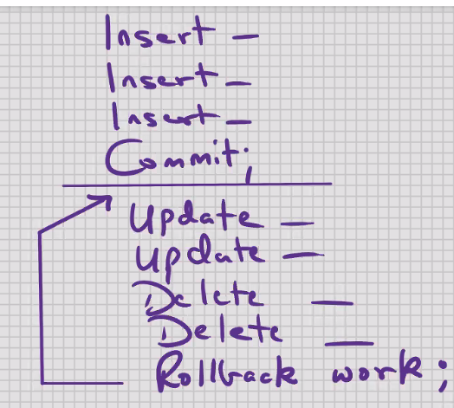

* Work is optional in MySQL
* Only the DML commands are affected by Rollback and Commit
* **Any DDL command automatically commits; not only will it commit itself, it will Commit all the DML changes before it.**
* When you EXIT from SQL, the system automatically Commits
* Any kind of power failure, network failure , system failure, PC reboot, window close, improper exit from SQL, etc, ; your last uncommitted Transaction is automatically Rolled back

**SAVEPOINT**

* A savepoint is a point within your work
* Savepoint is similar to a bookmark
* Savepoint is similar to a MileStone within your transaction
* **You can rollback to a savepoint**
* **YOU CANNOT COMMIT TO A SAVEPOINT**
* Commit will save all the DML changes since the last committed state
* When you Rollback or Commit, the intermediate Savepoints are cleared; if you want to use them again, then you will have to reissue them in some new Work
* Rollback work to pqr;

Or

* Rollback to pqr;
* Work is optional in rollback;
* You can only rollback sequentially

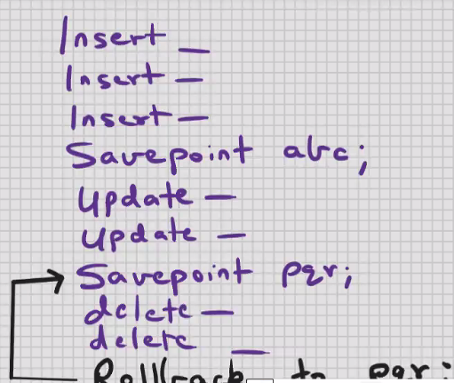 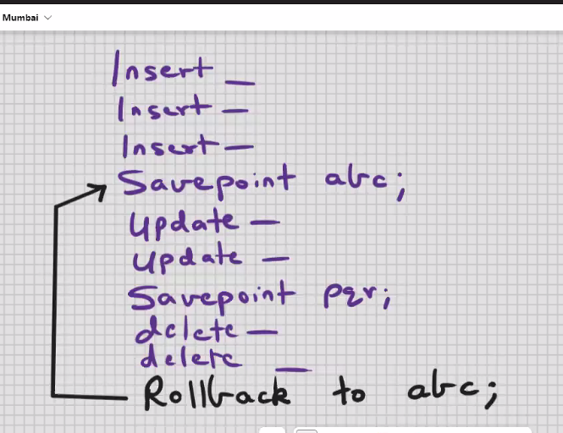

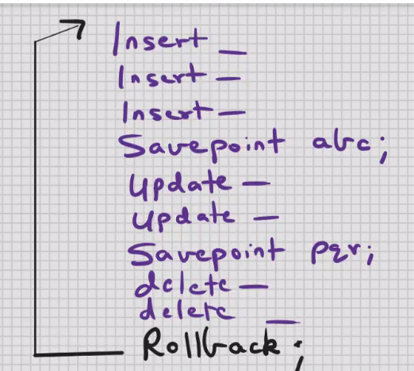

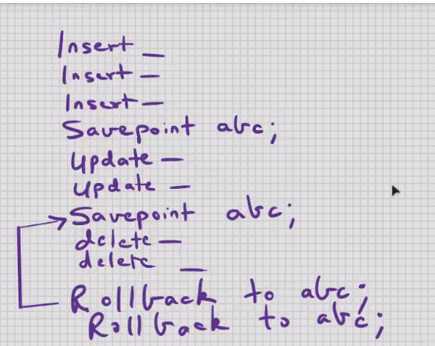

* Within a transaction, you can have 2 Savepoints with the same name
* The latest Savepoint supercedes the previous one
* The older Savepoint no longer exists

11 - 10 - 2024

MYSQL – Read and write consistency

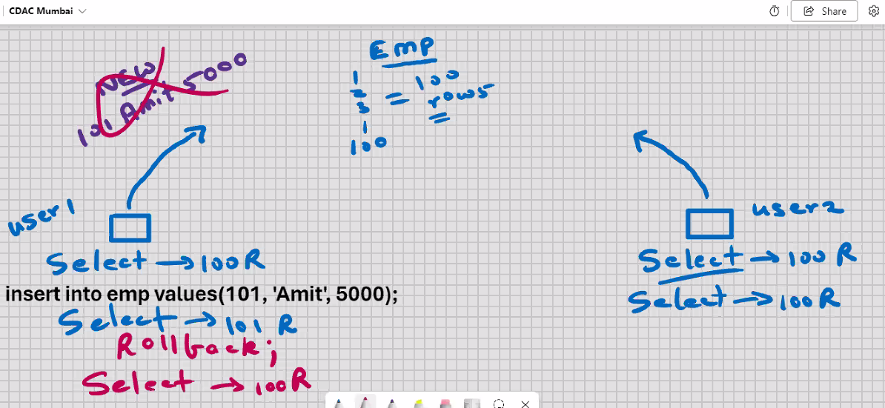

* In a muti-user environment when you SELECT from a table you can view ONLY the committed data of all users plus/union changes made by the you
* **ACID Properties in RDBMS :-**
* ***Atomicity***
* The entire transaction takes place at once or doesn’t happen at all (e.g. You withdraw Rs. 500/- from your Bank Account……….)
* ***Consistency***
* The database must be consistent before and after the transaction (e.g. Same as above , Deposits and balance tables )
* ***Isolation***
* Multiple transactions occur independently without interference
* ***Durability***
* The changes of a successful transaction are permanently, even if later the system failure occurs

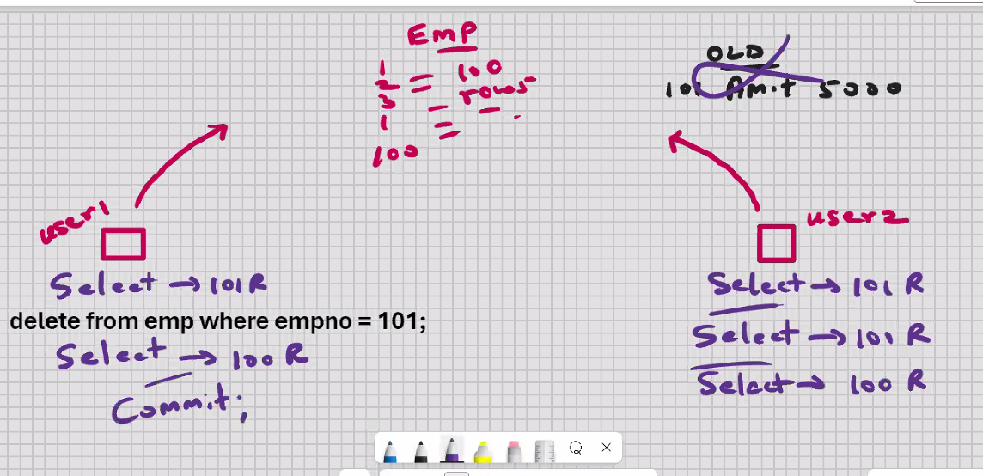

* **OPTIMISTIC LOCKING 🡪**
* **Automatic row locking mechanism in MySQL:-**
* When you UPDATE or DELETE a row, that row is automatically “locked” for other users
* ROW LOCKING IN MySQL IS AUTOMATIC
* When you UPDATE or DELETE a row, that row becomes READ_ONLY for other users
* Other users can SELECT from that table; they will view the old data “before” your changes
* Other users can INSERT rows into that table
* Other users can UPDATE or DELETE “other” rows from that table
* No other user can UPDATE or DELETE your locked row till you have issued a Rollback or Commit
* LOCKS ARE AUTOMATICALLY RELEASED WHEN YOU ROLLBACK OR COMMIT
* **PESSIMISTIC LOCKING 🡺**
* Lock the rows manually in advance “BEFORE” issuing UPDATE or DELETE

To lock the rock manually :-

* You have to use SELECT statement with the FOR UPDATE clause

Select * from emp

Where empno = 101

For update;

* LOCKS are automatically

MySQL – SQL – Number Functions

* Select round(sal) from emp;
* Select round(sal, 1) from emp;
* Select round(sal, 2) from emp;
* Select round(sal, -2) from emp; // round off to nearest hundred ex 1875.545 to 1900
* Select round(sal, -3) from emp;

Uses:-

1. Age calculation
2. Time calculation

* Select truncate(sal, 0) from emp;
* Select truncate(sal, 1) from emp;
* Select truncate(sal, 2) from emp;
* Select truncate(sal, -2) from emp;

Ceil 🡪 ceiling

* Select ceil(sal) from emp; 🡨 if there is ANY value at all in the decimal, it will add 1 to the whole number

Uses :-

1. Bill payments
2. Interest payments
3. EMI payments

Floor 🡪

Select floor(sal) from emp;

1234

1875

1352

1748

* Select truncate(3.6, 0) , floor(3.6) , truncate(-3.6, 0) , floor(-3.6)

From dual; | | | |

3 3 -3 -4

* Select sign(-15) from dual; //expected output -1 , 1, 0

-1

Uses: -

1. Check if number is positive or negative

If x > 0 then

………………………………;

Elseif x < 0 then

……………………………….;

Elseif;

1. Sign(temperature)
2. Sign(blood_group)
3. Sign(sensex)
4. Sign(time1 – time2)
5. Sign(qty_in_stock)
6. Sign(dist1 – dist2)
7. Sign(acceleration)
8. Sign(customertraffic)
9. Sign(velocity1 – velocity2)
10. Sign(SP - CP)
11. To find the greater of 2 numbers

a -> 10

b -> 20

sign(a-b)

* Select mod(9,5) from dual;

4

* Select mod(8.22 ,2.2) from dual;

1.62

* Select sqrt(81) from dual; 🡨 only works with positive number

9

MYSQL – Date and Time Functions and Formats🡪

1. Date, time, datetime, year
2. 1st Jan 1000 AD to 31st Dec 9999 AD
3. No problem of Y2k
4. ‘-838:59:59’ to ‘838:59:59’
5. ‘YYYY-MM-DD’ is the default date format in MySQL
6. ‘YYYY-MM-DD’ or ‘YY-MM-DD’
7. 1970 is the year of the Epoch
8. 00:00:00 (12 am midnight is the default value for time)
9. Date1 – date2, time1 – time2, datetime1 – datetime2
10. Internally date is stored as fixed- length number and it occupies 7 bytes of storage

* Select sysdate() from dual; // it return date and time when the statement executed

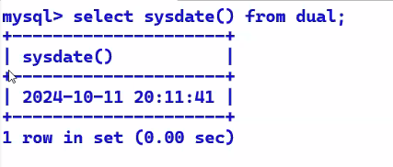 // returns DB server machine date and time

* Select now() from dual; 🡨 returns date and time when the statement began to execute

2024-10-11 20:11:41 // returns DB server machine date and time

* Select sysdate(), now(), sleep(10), sysdate(), now() from dual;

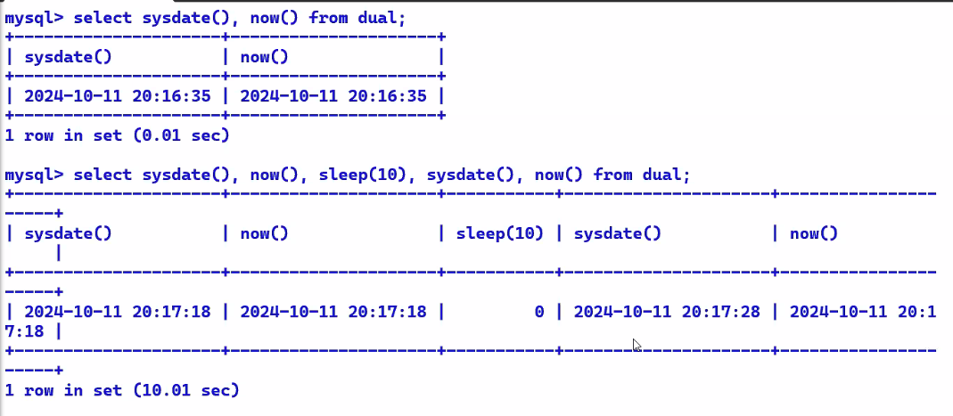

Sysdate()

Uses:-

1. Date and time displays

Now()

Uses:-

1. Maintain logs of user actions/ operations

* Select adddate(sysdate(), 1) from dual;

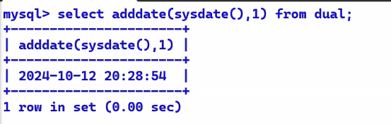

* Select adddate(sysdate(), 2) from dual;
* Select adddate(sysdate(), 7) from dual; // date after 1 whole week
* Select adddate(sysdate(), -1) from dual; // yesterday date
* Select datediff(sysdate(),hiredate) from emp; -returns number of calender days between the two

371.5

295

* Decimal above is the remainder hours, minutes, and seconds as a fraction of day
* Select date_add(hiredate, interval 2 months) from emp; // add 2 months

2023-12-15

2024-02-29

2024-03-15

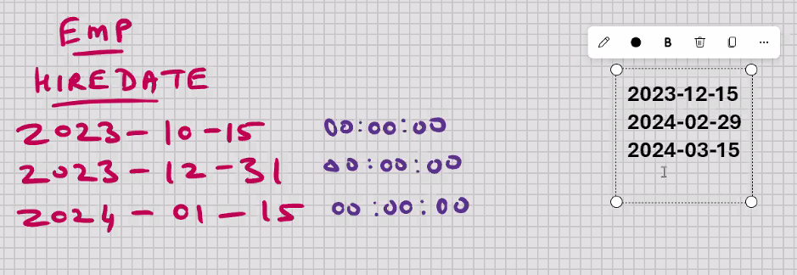

* Select date_add(hiredate, interval -2 months) from emp; //subtracting two months
* Select date_add(hiredate, interval 1 year) from emp; // add a year
* Select date_add(hiredate, interval -1 year) from emp; // subtract a year
* Select adddate(sysdate(), 1/(24*60*60)) from emp;
* Select last_day(hiredate) from emp; // gives me last date of the month

2023-10-15 -- 2023 -10-31

2023-01-04 -- 2023 -01-31

Uses:-

A . attendance_calc

B. Interest_calc

Select last_day(‘2024-10-11’) from dual;

* Select dayname(sysdate()) from dual;

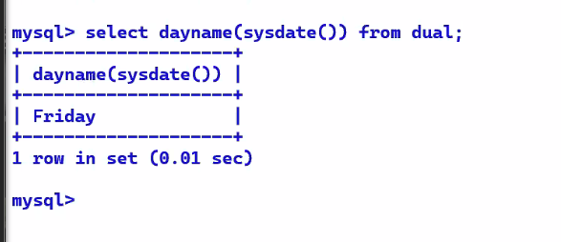

🡪select upper(dayname(sysdate())) from dual;

🡪select substr(dayname(sysdate()), 1, 3) from dual;

Fri

* select addtime(‘2010-01-15 10:00:00’ , ‘1’) from dual;

 // adds a second

* select addtime(‘2010-01-15 10:00:00’ , ‘-1’) from dual;
* select addtime(‘2010-01-15 10:00:00’ , ‘1:30:45’) from dual;

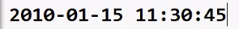

* select addtime(‘2010-01-15 10:00:00.000000’ , ‘1:30:45.000001’) from dual;

13-10-2024

MYSQL – SQL – List functions

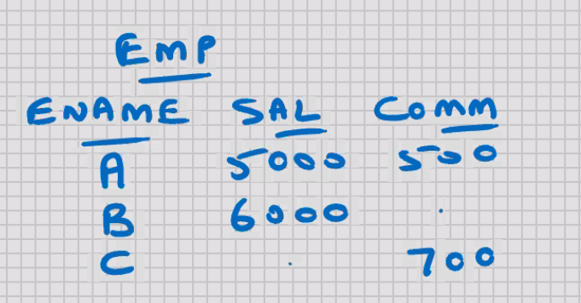

* independent of datatypes
* select * from emp where comm = null;
* any comparison done with null, returns null

Pessimistic querying 🡪 searching for null values

* select * from emp where comm is null;
* Special operator 🡪 is null

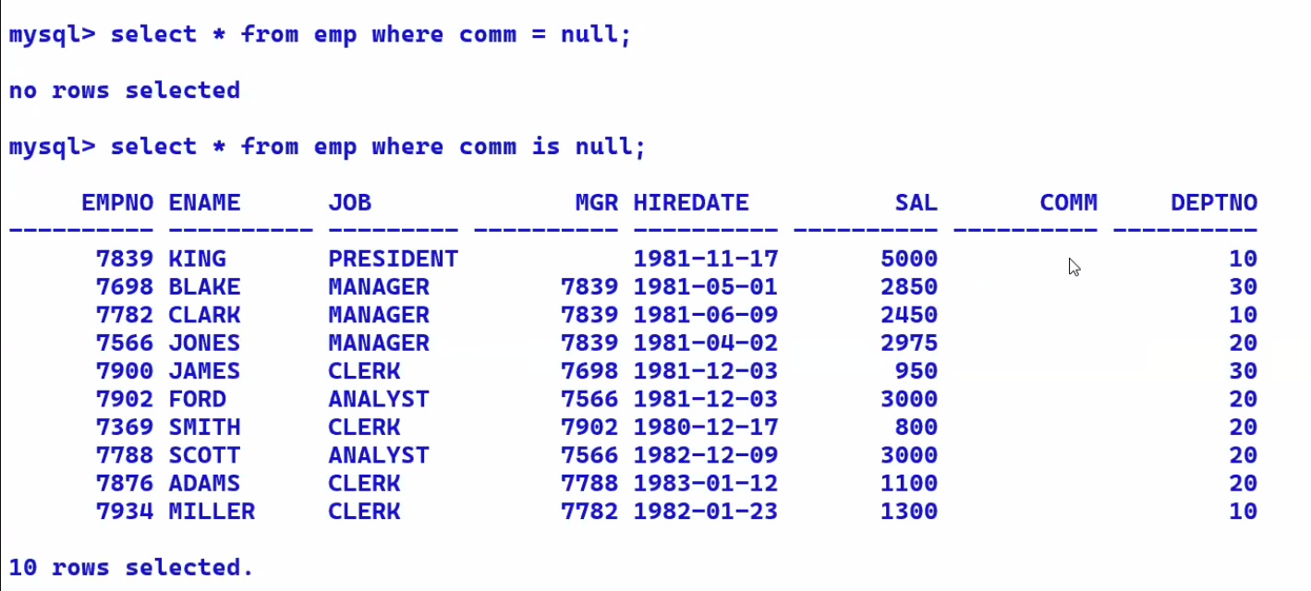

* select * from emp where comm != null;
* any comparison done with null, returns null
* select * from emp where comm is not null; // this works
* select sal + comm from emp; // to find net value

5500

.

.

* any operation done with null, returns null
* select sal + ifnull(comm, 0) from emp; // ifnull is a function 🡪 if comm is null then return 0 else return comm end if;

5500

6000

.

* select ifnull(sal, 0) + ifnull(comm, 0) from emp;

5500

6000

700

* ifnull(comm, 0)
* ifnull(comm, 100) // we can put any value for comm
* ifnull(city, ‘Mumbai’)
* ifnull(orderdate, ‘2024-04-01’)

 

* select greatest(sal,3000) from emp; 🡨 return the greatest of the two
* uses:-

1. to set a lower limit on some value

* e.g.:-

bonus = 10% sal, min bonus = 300

* select greatest(sal*0.1, 300) from emp;
* select greatest(sal, 3000, 4000, 5000, 10000) from emp;

greatest(val1, val2, val3, ……, val255)

greatest(col1, col2, col3, …….., col255)

greatest(‘str1’, ‘str2’, ‘str3’)

greatest(‘date1’, ‘date2’, ‘date3’, ’date4’)

greatest(‘time1’, ‘time2’, ‘time3’)

greatest(‘datetime1’, ‘datetime2’ , ‘datetime3’)

set x = greatest(a,b,c,d);

* select least(sal, 3000) from emp; 🡨 returns the smaller of two

1000

2000

3000

3000

3000

* uses:-

1. to set an upper limit on some value

* e.g.

cashback = 10% amt, max cashback = 300

* select least(amt*0.1, 300) from orders;
* select least(sal, 3000, 4000, 5000, 10000) from emp;
* least works with all datatypes

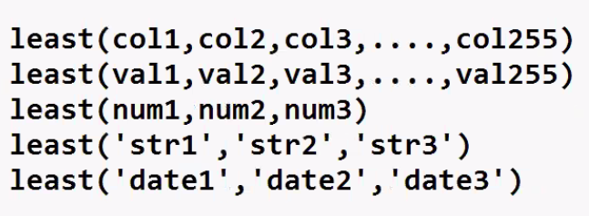

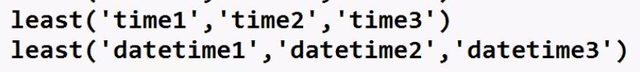

set x = least(a, b, c, d);

MYSQL - SQL – CASE keyword

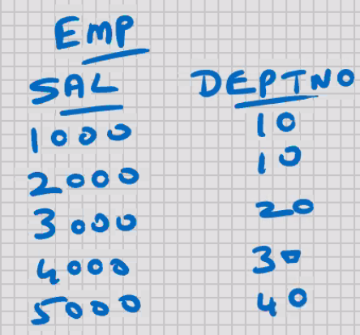

* select

case

when deptno = 10 then ‘Training’

when deptno = 20 then ‘Exports’

when deptno = 30 then ‘Marketing’

else ‘Others’

end “DEPTNAME”

from emp;

DEPTNAME

Training

Training

Exports

Marketing

Others

* if you don’t specify ELSE, and if DEPTNO 40 is present in the table, then it returns a null value

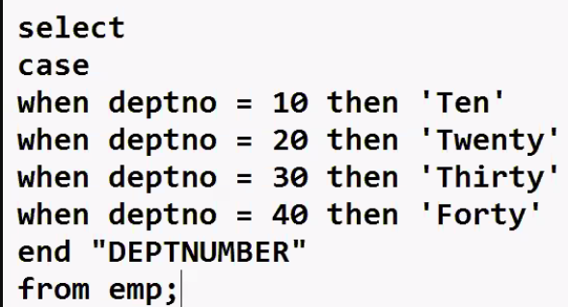

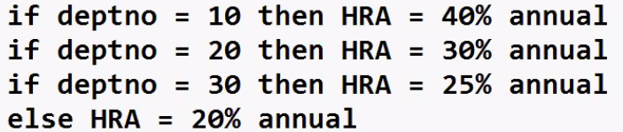

* select deptno, ename, sal, sal*12, “ANNUAL”,

case

when deptno = 10 then sal*12*0.4

when deptno = 20 then sal*12*0.3

when deptno = 30 then sal*12*0.25

else sal*12*0.2

end “HRA”

from emp

order by 1;

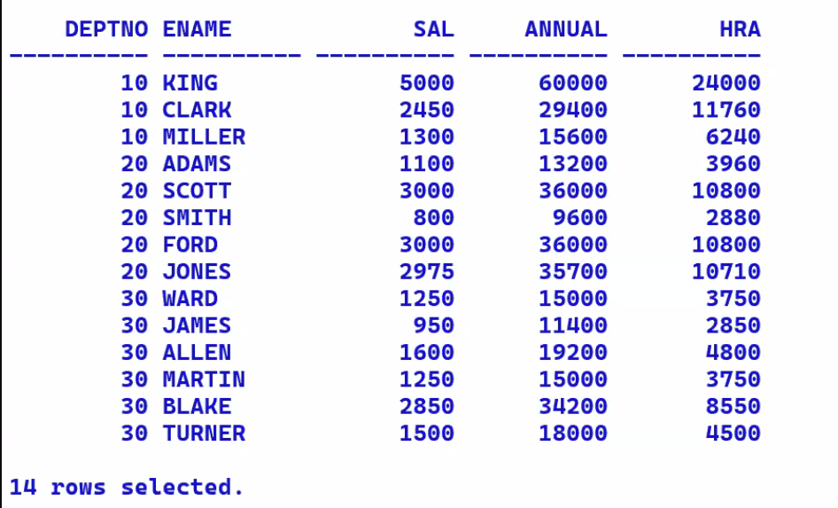

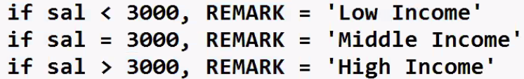

* select

case

when sign(sal-3000) = 1 then ‘High Income’

when sign(sal-3000) = -1 then ‘Low Income’

else ‘Middle Income’

end “REMARKS”

from emp

order by 2;

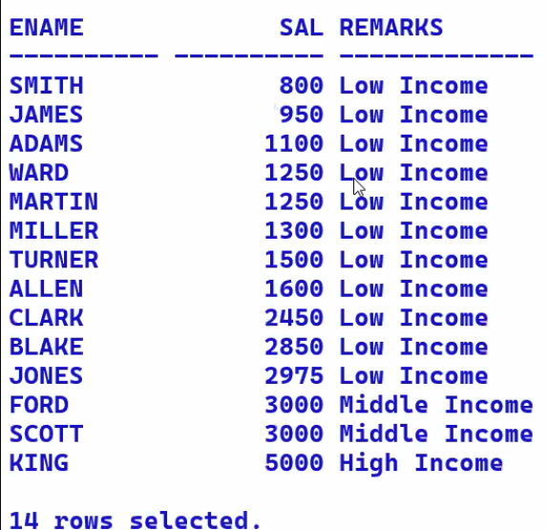

MYSQL – SQL – Environment Functions

🡪 use cdacmumbai;

To check which database we are connected to

* select database() from dual;
* select user() from dual;

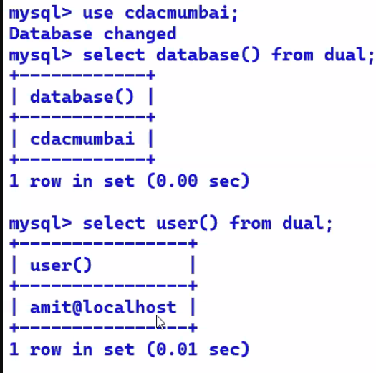

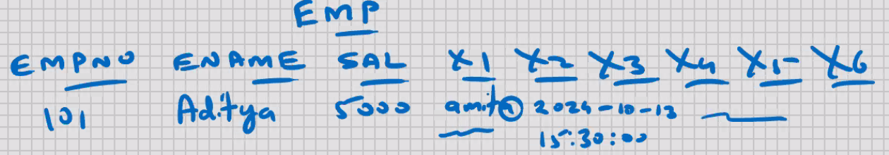

* show character set; // shows what languages are currently available in my current installation

MYSQL – SQL - GROUP/ AGGREGATE FUNCTIONS

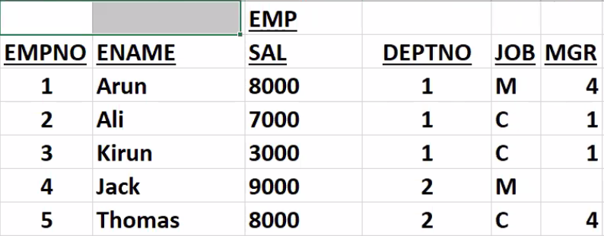

M – manager C – clerk

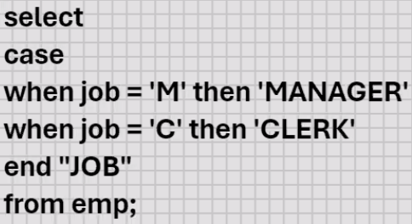

Single- row functions :- // what we have done till now

* operate on 1 row at a time
* Character , number, Date and time, list , environment functions
* E.g. upper(ename), round(sal), etc

Multi- row functions:-

* Operate on multiple rows at a time
* Group Functions
* E.g. sum(sal)
* Select sum(sal) from emp;

35000

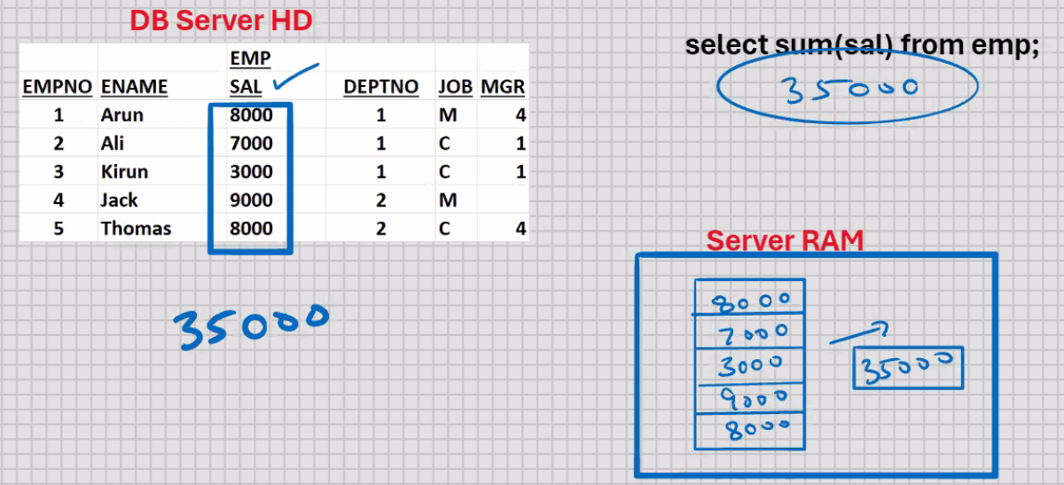

[ARRAY]

ASSUMPTION :-

* 4TH row the sal is null :-
* select sum(sal) from emp; 🡨 null value are not counted by group functions

26000

* select avg(sal) from emp;

26000/4 -> 6500

* select avg(ifnull(sal)) from emp;

26000/5 -> 5200

* select min(sal) from emp;

3000

* select min(ifnull(sal)) from emp;

0

* select max(sal) from emp;

8000

* select count(sal) from emp; *🡨 returns a count of number of rows where SAL is not having a null value*

4

* select count(*) from emp; *🡨 returns a count of total number of rows in the table*

5

* select count(*) – count(sal) from emp; *// returns a count of those who are not receiving a salary*
* select max(sal)/min(sal) from emp;

8000/3000 🡪 2.67

* select sum(sal)/count(*) from emp*; 🡨 FASTER*

26000/5 🡪 5200

* select avg(ifnull(sal, 0)) from emp;  *🡨 SLOWER*

26000/5 🡪 5200

ASSUMPTION :-

* 4th row sal is 9000 :-
* Select sum(sal) from emp

Where deptno = 1;

18000

* Select avg(sal) from emp

Where job = ‘C’;

6000

* *COUNT-QUERY (Counting the number of query hits):-*
* Select count(*) from emp

Where sal > 7000;

3

* Sum(column)
* Avg(column)
* Min(column)
* Max(column)
* Count(column)
* Count(*)
* Stddev(column)
* Variance(column)

Min, max, count can be used on other columns also like min(ename), min(hiredate), max(ename), max(hiredate), count(ename), count(horedate)

* *SUMMARY REPORT :-*
* Select count(*), min(sal), max(sal), sum(sal), avg(sal) from emp;

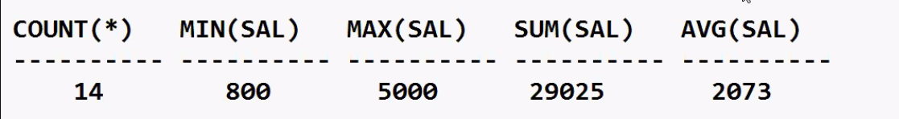

RESTRICTION #1 :-

* You cannot SELECT column of table alongwith a group function
* Select count(ename) , max(sal) from emp;
* Select ename, max(sal) from emp; 🡨ERROR

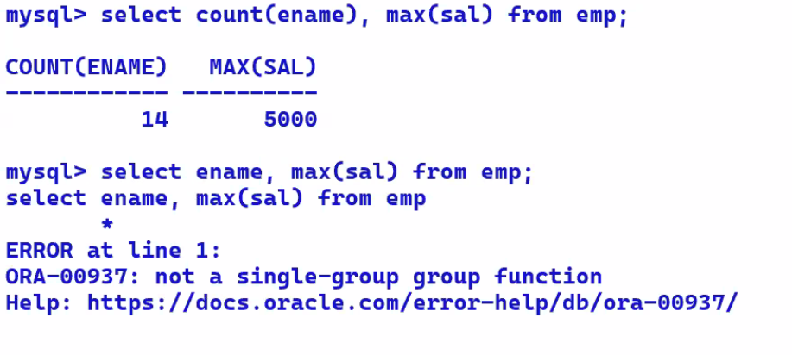

RESTRICTION #2 :-

* You cannot select a single-row function alongwith a group function
* Select upper(ename) , max(sal) from emp; 🡨ERROR

RESTRICTION #3 :-

* You cannot use group function in the WHERE clause
* Select * from emp where sal > avg(sal); 🡨ERROR

MYSQL – SQL – GROUP BY clause (V.Imp)

* Used for grouping

WHERE clause 🡪 used for searching

ORDER BY clause 🡪 used for sorting

FOR UPDATE clause 🡪 used for locking the rows manually

GROUP by clause 🡪 used for grouping

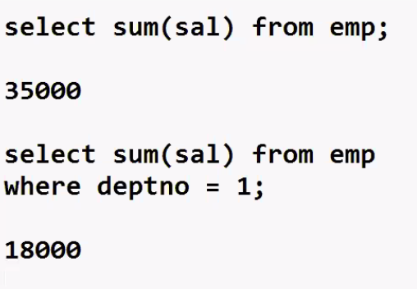

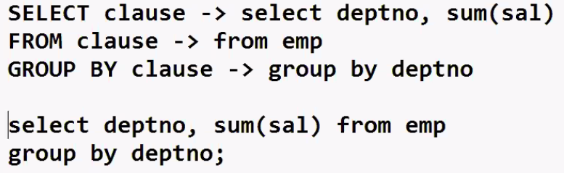

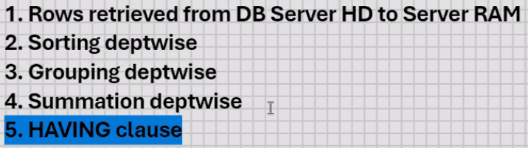

Sum(sal) deptwise:-

Select deptno, sum(sal) from emp

Group by deptno;

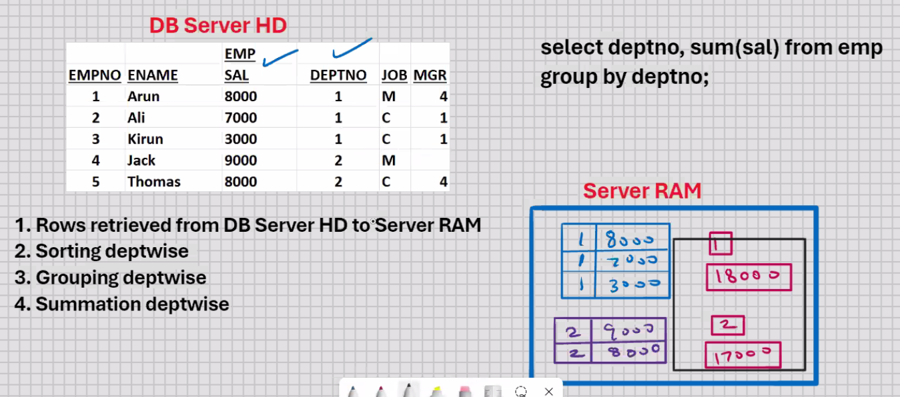

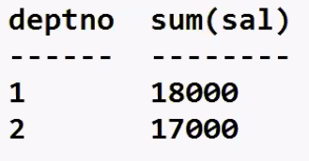 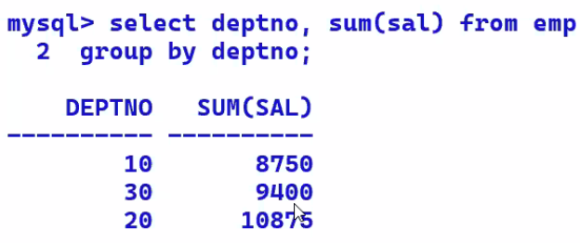

Rule #1 :-

* Besides the group function, whichever column is present in SELECT clause, it has to be present in GROUP BY clause
* Select deptno, sum(sal) from emp; 🡨 ERROR

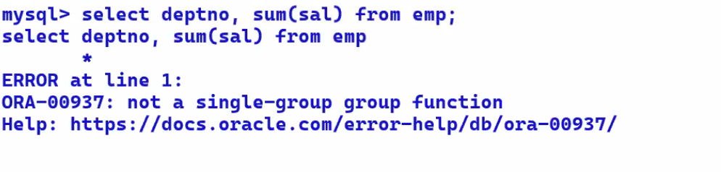

Rule #2 :-

* Whichever column is present in GROUP BY clause, it may or may not be present in SELECT clause

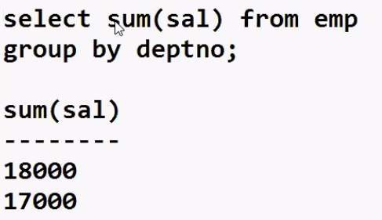

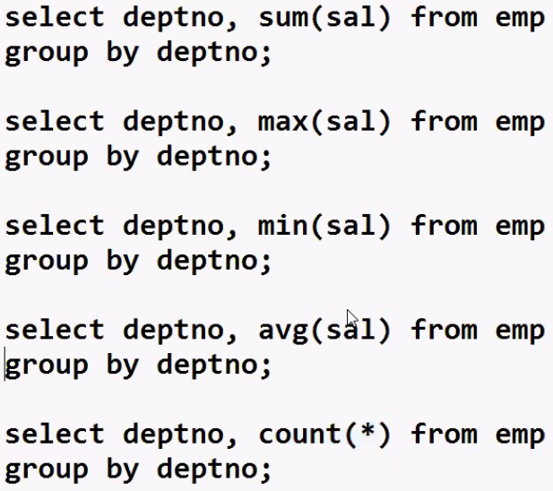

2D – QUERY 🡪 any SELECT statement with a GROUP BY clause is known as a 2D query, because you can plot a graph from the output

* MS EXCEL , oracle Graphics , Orace Apex, etc. used for making graphs
* Select deptno, sum(sal) from emp

Where sal > 7000 // where clause should be specified before Group By clause

Group by deptno;

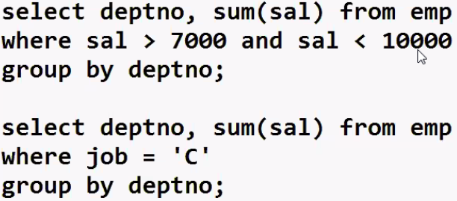

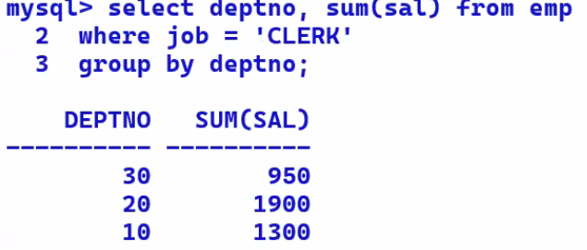

* Select job, sum(sal) from emp

Group by deptno; 🡪 ERROR

* Select deptno, job, sum(sal) from emp

Group by deptno , job;

* There Is no upper limit on the number of columns in GROUP BY clause

Select ………..

Group by city, state, city;

* If you have a large number of rows in the table, and if you have a large number of columns in GROUP BY clause, then the SELECT statement will be very slow, because that much sorting has to take place in server RAM
* If you have 1 column in GROUP BY clause 🡪 2D query
* If you have 2 columns in GROUP BY clause 🡪 3D query
* If you have 3 columns in GROUP BY clause 🡪 4D query

Etc.

Known as Multi-dimensional queries(also known as spatial queries)

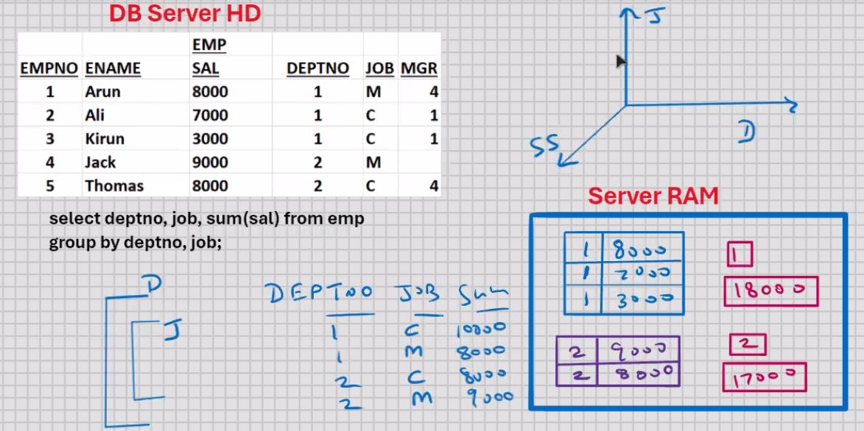

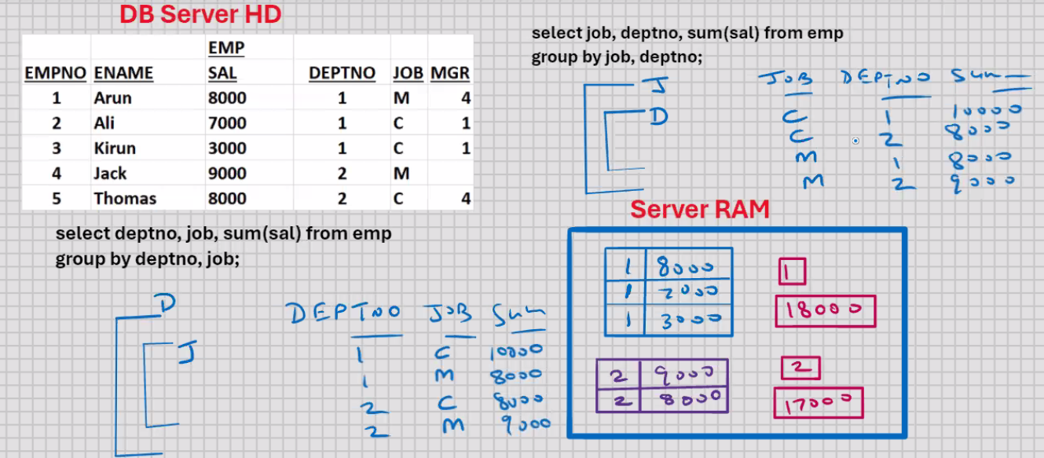

Output will be same whether you group by deptno, job or job, deptno but it will difference in computing time [faster] [slower]

🡪select ……………….

Group by city , country, district, state; 🡨 slow

🡪select …………………..

Group by country, state, district , state; 🡨 fast

* The position of columns in SELECT clause and the position of columns in GROUP BY clause need not be the same
* The position of columns in SELECT clause will determine the position of columns in the output; this you will write as per User requirements
* The position of columns in GROUP BY clause will determine the sorting order, grouping order, summation order, and hence the speed of processing ; this you will write as per count(distinct(columnname))
* Select count(distinct deptno), count(distinct job) from emp;
* Select deptno, sum(sal) from emp

Group by deptno;

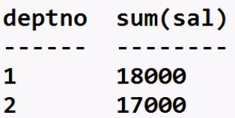

* Select deptno, sum(sal) from emp

Group by deptno

Having sum(sal) > 17000;

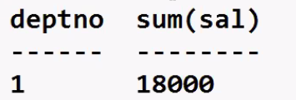



6. ORDER BY clause

* WHERE Clause is used for searching
* Searching takes place in DB server HD
* WHERE clause is used to restrict the rows
* WHERE clause is used to retrieve the rows from DB server HD to Server RAM
* HAVING clause works AFTER the summation is done

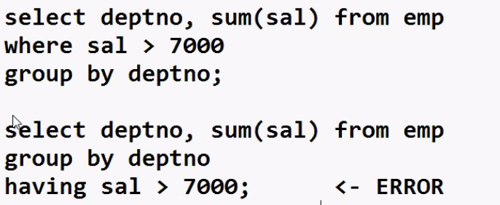

* Which ever column is present in SELECT clause, it can be used in HAVING clause
* Select deptno, sum(sal) from emp

Group by deptno

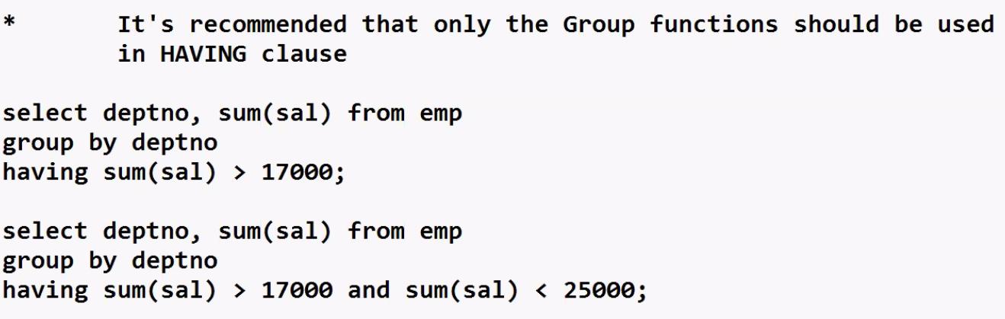Having deptno = 1; 🡨 WILL WORK BUT IT IS INEFFICIENT, INSTEAD SHOULD HAVE USED WHERE DEPTNO = 1

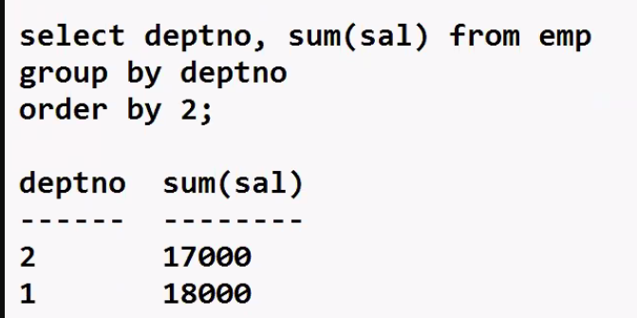

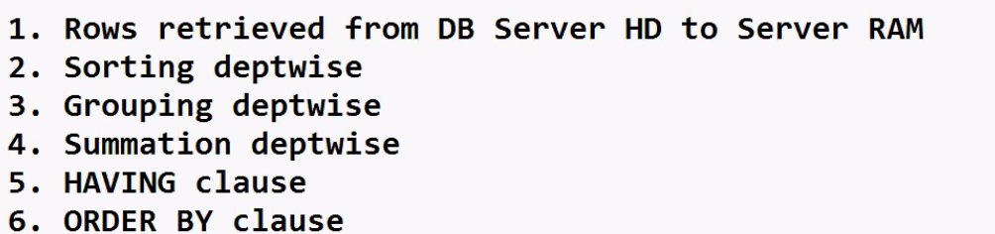

* ORDER BY clause is the LAST clause in SELECT statement
* Select……………..from……………..

Where…………..

Group by ………………….

Having ………………..

Order by…………………..;

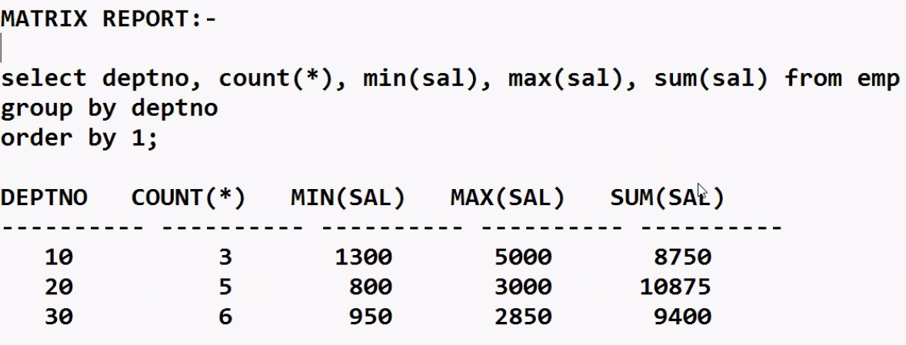

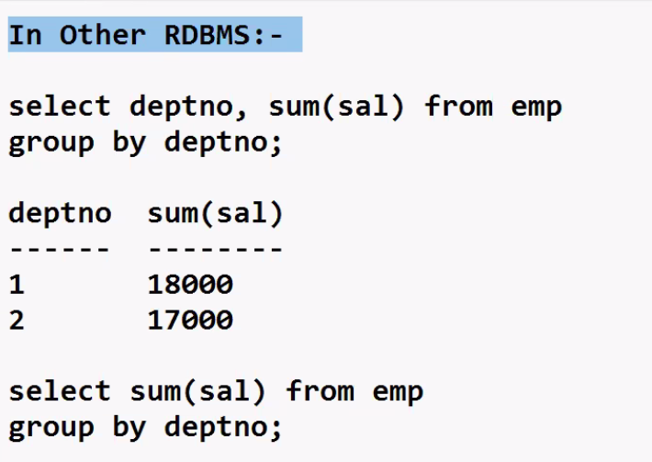

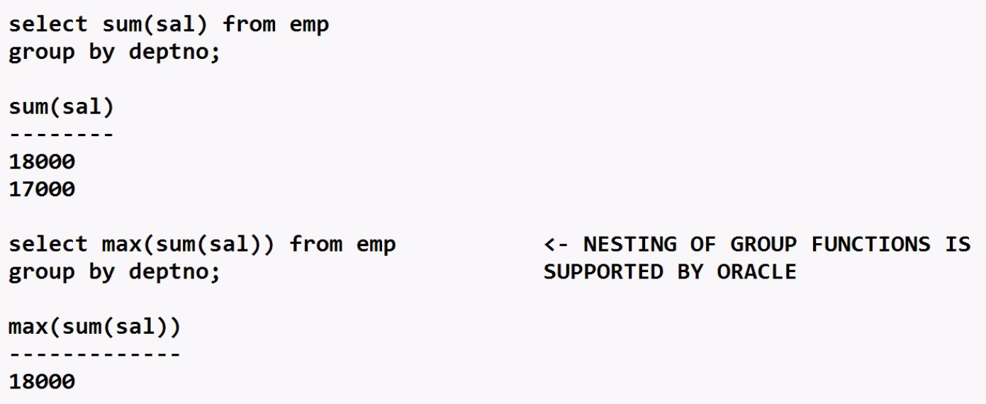

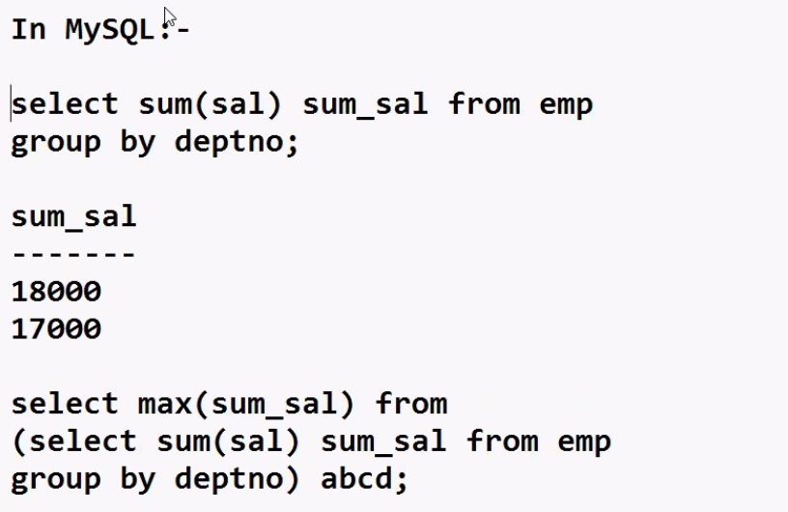

Abcd table is a temporary table in server ram and its life is only for this select statement after this it is not available

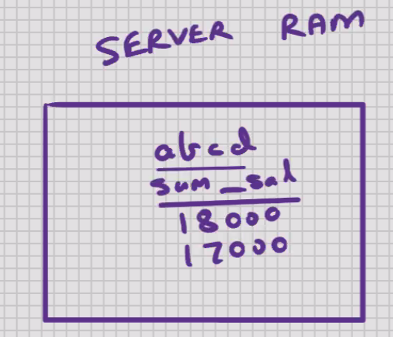

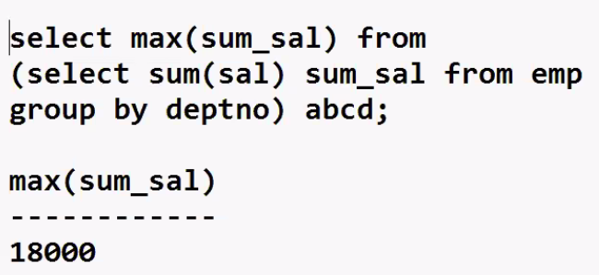

MYSQL – SQL – JOINS (V.Imp)

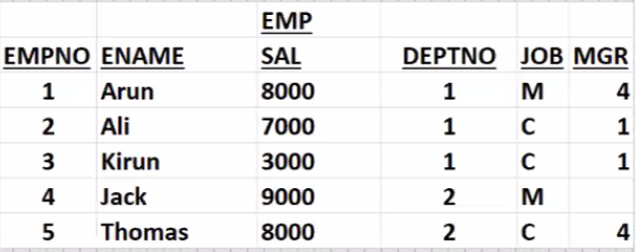

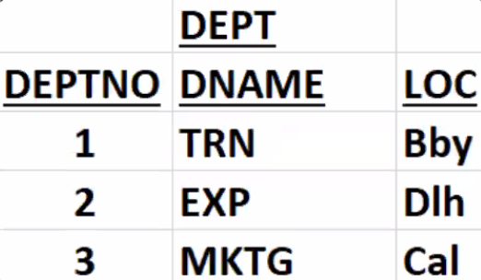

* All the data is stored in one table, data is stored in , multiple tables
* If you want to see the columns of 2 or more tables , then you will have to write a join

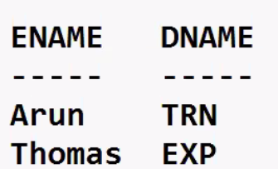

* Select dname, ename form emp, dept

Where dept.deptno = emp.deptno;

Dept.deptno 🡺 tablename.columnname

Emp.deptno 🡪 tablename.columnname

Dept 🡪 driving table // table should be less no of rows

Emp 🡪 driven table

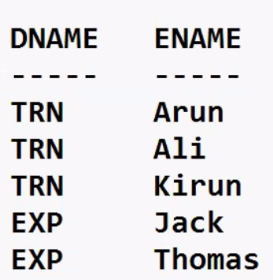

* The position of columns in SELECT clause will determine the position of columns in the output;

This you will write as per client req.



* WHERE clause can be written in any sequence

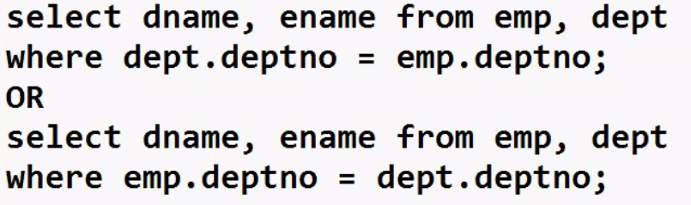

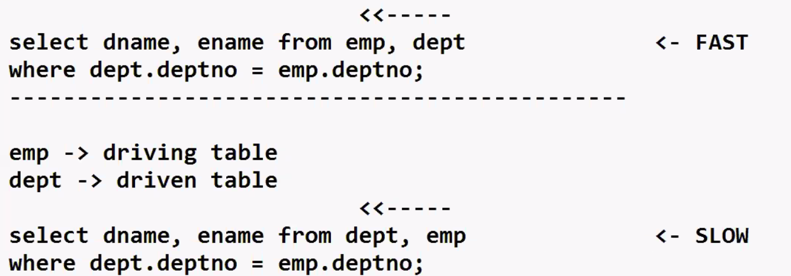

* In order for the join to work faster, preferably the driving table should be table with lesser number of rows
* The common column in both the tables is DEPTNO; the common column that is present in both the tables, the columnname need not be the same in both the tables, because the same column may have a different meaning in the other table

e.g. EXPORT and IMPORT, PURCHASE and SALE, etc

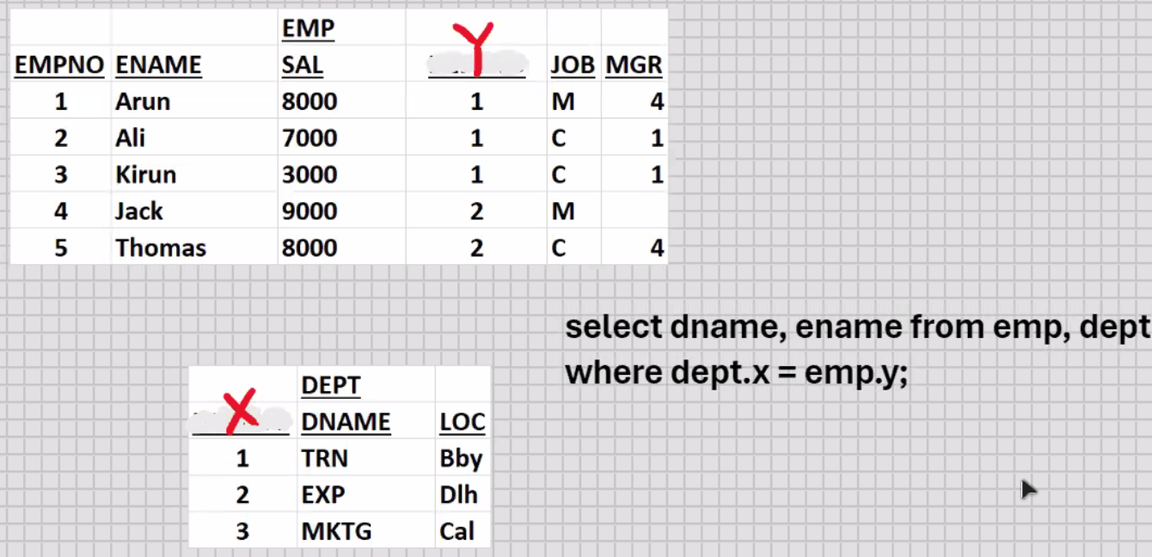

* What matters is the datatype of common column in both the tables should be the same

And there has to be some logical reason on whose basis you are writing the join

 // output is meaningless

* To make the output more presentable:-



* Its good to display lots of columns in the output; it becomes richer and more meaningful

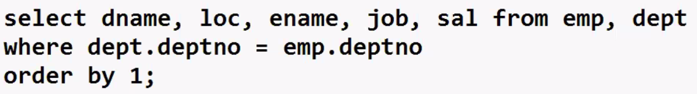

* To display all the columns from both the tables



* Column ambiguously defined (if the common column had different column names in both the tables, then this problem would not have arisen)

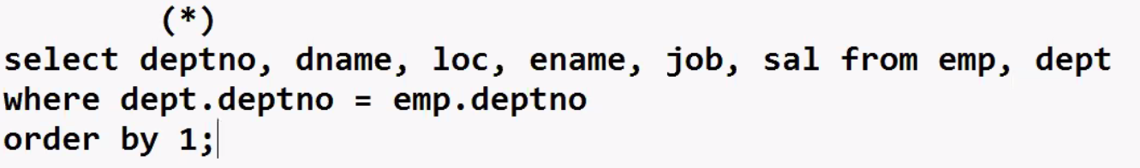

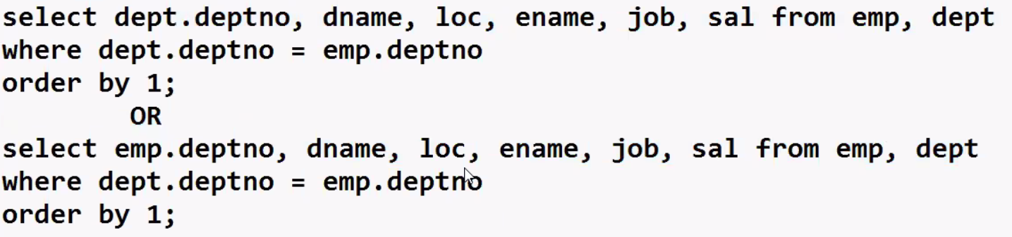

* Its good programming practice to use tablename,columnnane in all the columns, because it makes the SELECT statement more readble

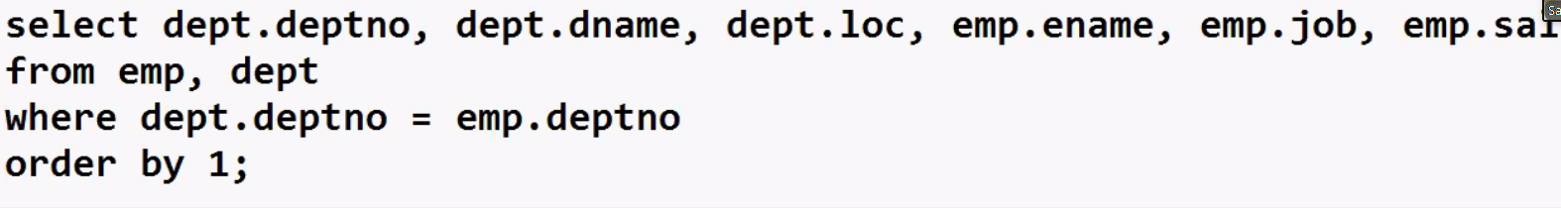

14-10-24

MYSQL – SQL – JOINS

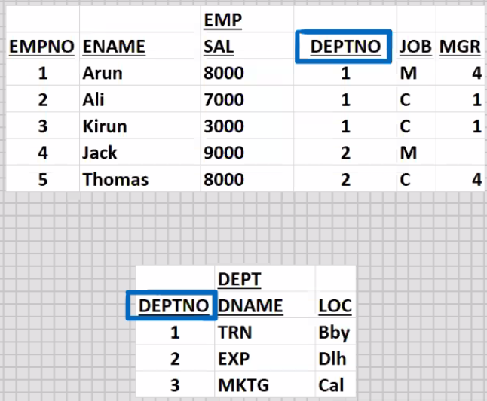

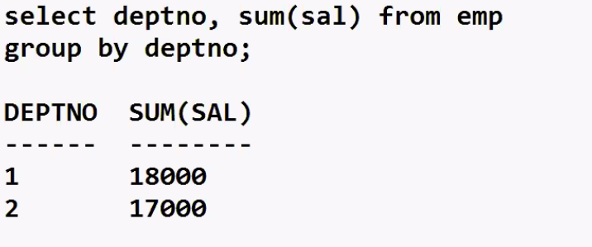

* select dname, sum(sal) from emp, dept

where dept.deptno = emp.deptno

group by dname;

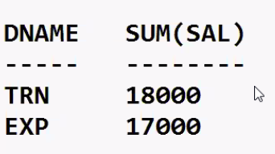

* select upper(dname), sum(sal) from emp, dept

where dept.deptno = emp.deptno

group by upper(dname)

having sum(sal) >10000

order by 1;

=====================================================================================

**TYPES OF JOINS (5) :-**

1. **Equijoin 🡪 (natural join)**
   * Join based on equality condition
   * Shows matching rows of both the tables
   * Uses :-
2. DNAME, ENAME
3. CNAME, SNAME
   * Most frequently used join (>90%) , hence its also known as Natural join

* select dname , ename from emp , dept

where dept.deptno = emp.deptno;

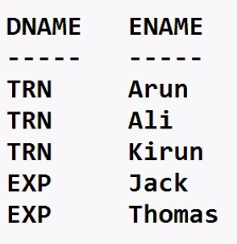

1. Inequijoin (Non - Equijoin)
   * Join based on inequality condition
   * Shows non- matching rows of both the tables
   * Uses :-
2. Exception Reports
3. Who are the employees who dont belong to TRN
4. Who are the customers who haven’t made the payment

* select dname , ename from emp , dept

where dept.deptno != emp.deptno;

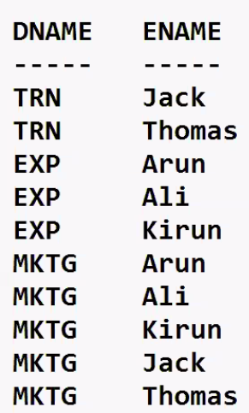

* select dname , ename from emp , dept

where dept.deptno != emp.deptno and dname= ‘TRN’;

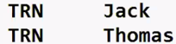

1. Outerjoin
   * Join with (+) sign or if you use the keyword “Outer”
   * Shows matching rows of both the tables

Plus

Non – matchinf rows of “Outer” table

* + Outer table 🡪 table which is on outer side of (+) sign
  + Outer table 🡪 table which is on opposite side of (+) sign
  + Uses:-

1. Use to generate MASTER - DETAIL report(PARENT – CHILD REPORT)

* Outerjoin is of two types 🡪
* Half outerjoin (1 do while loop , 1 for loop)

1. Right outerjoin
2. Left outerjoin

* Full outerjoin (Nested do while loop)
* Select dname, ename from emp, dept 🡨 Right Outerjoin

Where dept.deptno = emp.deptno (+);

[LHS] [RHS]

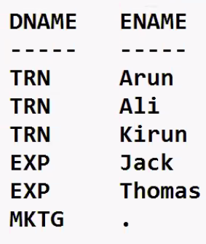 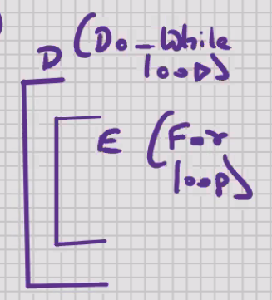

* Select dname, ename from emp, dept

Where dept.deptno (+) = emp.deptno ; 🡨 Left outerjoin

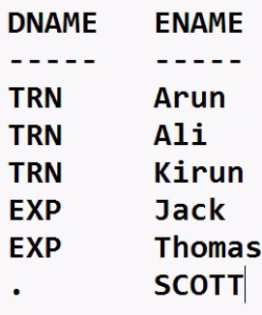 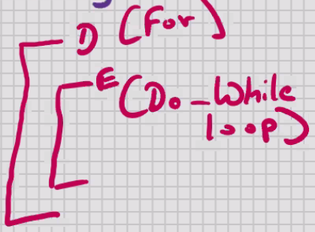

Full outerjoin (Nested do-while loop):-

* Shows matching rows of both the tables

Plus

Non – matching rows of both the tables

* UNION of right outerjoin and left outerjoin
* Select dname, ename from emp, dept

Where dept.deptno = emp.deptno (+)

**Union**

Select dname, ename from emp, dept

Where dept.deptno (+) = emp.deptno ;

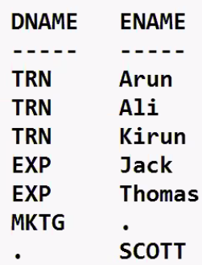

ANSI syntax for full outerjoin :-

* Select dname, ename from emp full outer join dept

on (dept.deptno = emp.deptno);

===========================================

ANSI syntax for right outerjoin :-

* Select dname, ename from emp right outer join dept

on (dept.deptno = emp.deptno);

===========================================

ANSI syntax for left outerjoin :-

* Select dname, ename from emp left outer join dept

on (dept.deptno = emp.deptno);

* (+) sign is not supported by MySQL
* ANSI syntax for right outerjoin is supported by mysql
* ANSI syntax for left outerjoin is supported by mysql
* ANSI syntax for full outerjoin is not supported by mysql

--------------------------------------------------------------------------------------------------------------------------------

* **To implement Full outerjoin in MySQL :-**

UNION of ANSI syntax for Right outerjoin and ANSI syntax for left Outerjoin

* Select dname, ename from emp right outer join dept

on (dept.deptno = emp.deptno)

**union**

Select dname, ename from emp left outer join dept

on (dept.deptno = emp.deptno);

* INNER JOIN 🡪 by default every join is INNER join; putting a (+) sign or using the keyword “Outer” is what makes it an Outerjoin
* DO NOT MENTION THIS IN INTERVIEWS UNLESS EXPLICITLY ASKED BY INTERVIEWER

1. Cartesian Join (cross join)
   * Join without a WHERE clause
   * Every row of driving table is combined with each and every row of driving table
   * It takes the cross product of 2 tables and therefore its also known as Cross join

* Select dname, ename from emp, dept; <- fast (LESSER the i/o between DB server HD and server ram , the faster it will be)
* Select dname, ename from emp, dept; <- slow (more the i/o between DB server HD and server ram , the slower it will be)

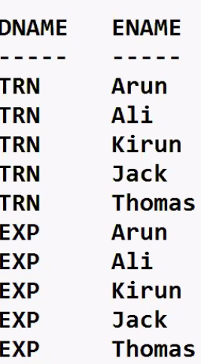

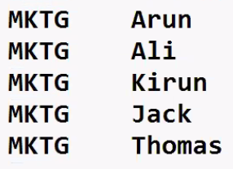

1. Self join
   * Joining a table to itself
   * Used when parent column and child column , both are present in the same table
   * Slowest join (based on recursion)
   * Uses :-
2. ENAME , MGRNAME

* Select a.ename, b.ename from emp b, emp a

where a.mgr = b.empno;

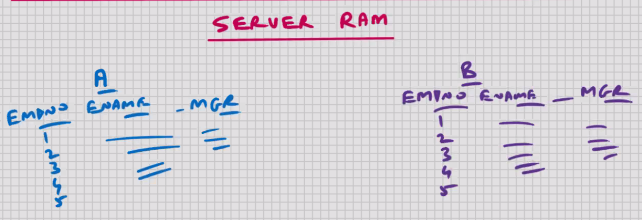

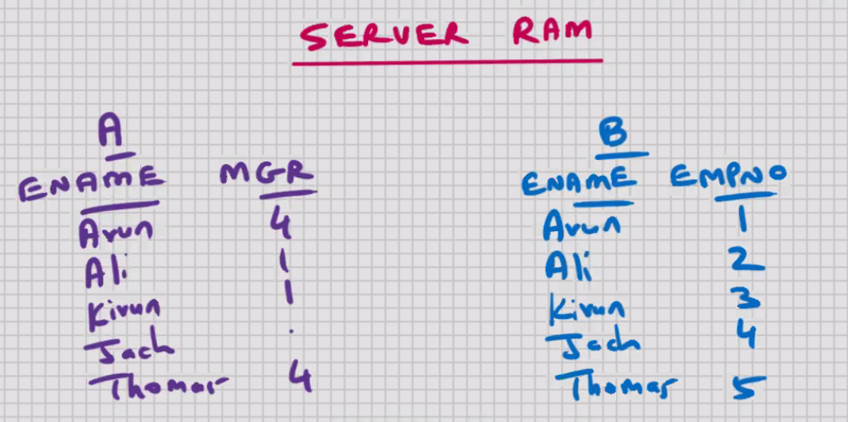

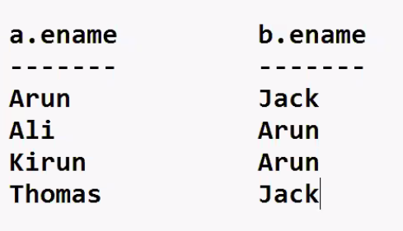

* Cartesian join is the fastest join , because there is no WHERE clause, and therefore there is no searching involved
* Joining 3 or more tables :-

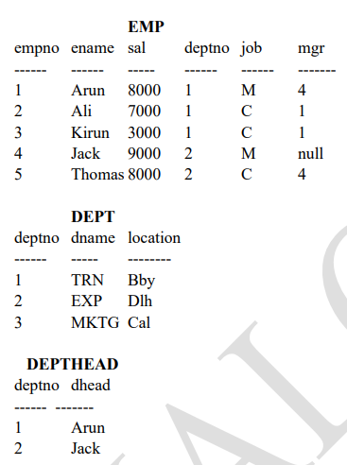

(5) (3) (2)

🡪 select dname, ename, dhead from emp, dept, depthead

where depthead.deptno = dept.deptno

and dept.deptno = emp.deptno;

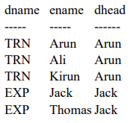 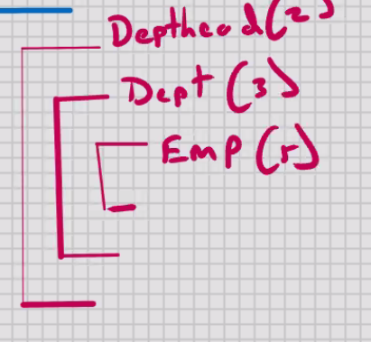

**Types of Relationships :-**

1 : 1 (Dept : Depthead) or (Depthead : Dept)

1 : Many (Dept : Emp) and (Depthead : Emp)

Many : 1 (Emp : Dept) and (Emp : Depthead)

Many : Many (Emp : Projects) or (Projects : Emp)

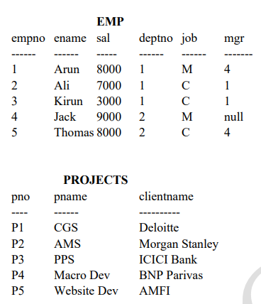



* INTERSECTION table is required for Many : Many Relationship

🡪 select pname, clientname, ename from projects_emp, emp, projects

where project_emp.pno = projects.pno

and projects_emp.empno = emp.empno;

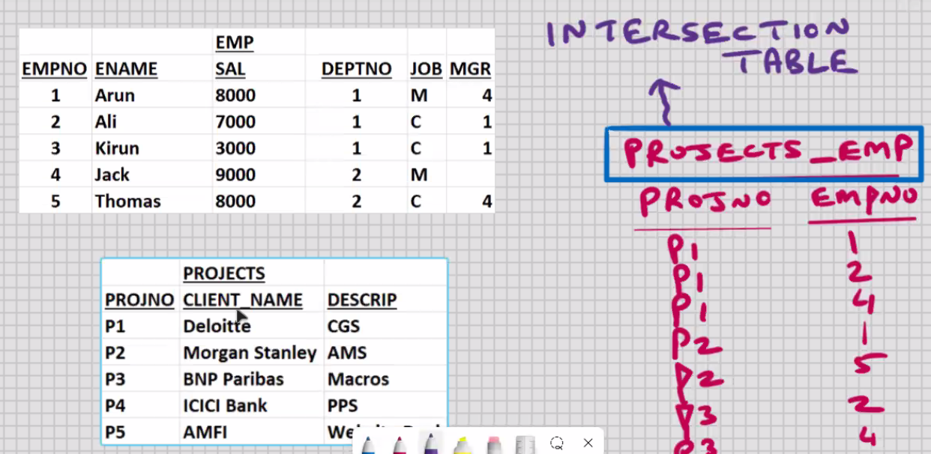

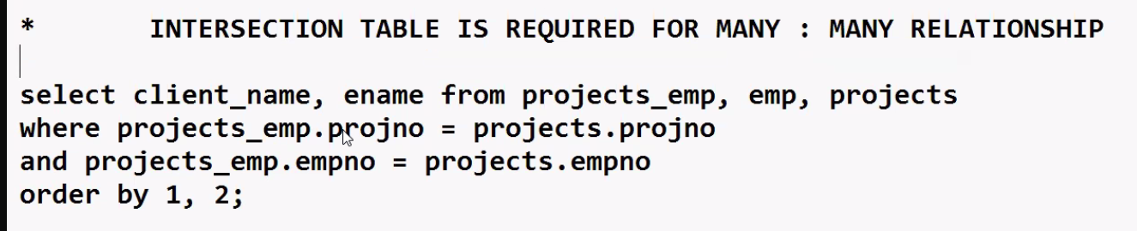

MYSQL – SQL – Sub- queries

* Nested queries (Query within query) (SELECT within SELECT)

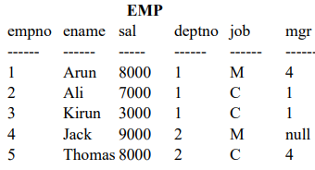

**Display the ENAME who is receiving min(sal): -**

* select ename from emp -> main query (parent/outer query)

where sal = (select min(sal) from emp); -> sub-query (child/inner query)

OUTPUT: - Kirun

* select ename from emp

where sal =

(select min(sal) from emp

where deptno =

(select...........));

* + max upto 255 levels for sub-queries (this limit of SQL can be exceeded with the help of views)
  + JOIN is FASTER than SUB-QUERY (the more the number of SELECT statements, the slower it will be)

**Display the 2nd largest sal: -**

* select max(sal) from emp

where sal <

(select max(sal) from emp);

**Display all the rows with same deptno as 'Thomas': -**

* select * from emp

where deptno =

(select deptno from emp

where ename = 'Thomas');

**Display all the rows with same job as 'Kirun': -**

* select * from emp

where job =

(select job from emp

where ename ='Kirun');

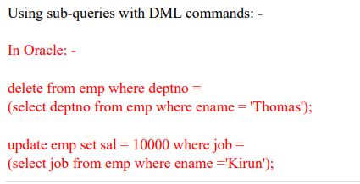

* above 2 commands will not work in MySQL
* IN MySQL you cannot update or delee from a table from which you are currently selecting

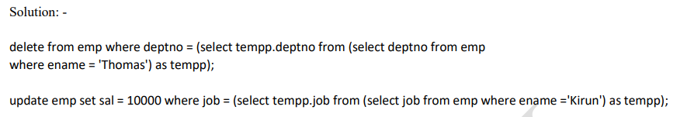

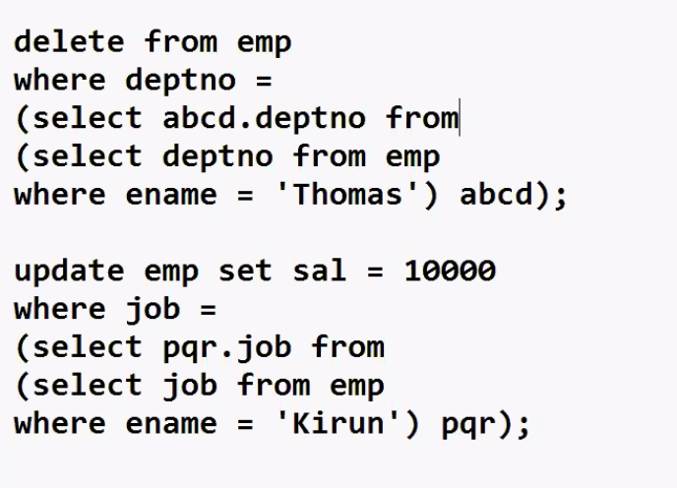

* Multi- row sub – queries (sub- query returns multiple rows) :-
* Display all the rows who are receiving a SAL = any of the Managers :-
* Select * from emp

Where sal in (8000, 9000)

(select sal for emp

Where job = ‘M’);

* Select * from emp

Where sal >= (8000)

(select min(sal) for emp

Where job = ‘M’);

To make it work faster :-

1. Try to solve the problem using a Join, because join is faster than sub-query
2. Try to reduce the number of levels for sub-queries
3. Try to reduce the number of rows returned by sub-query

Display all the rows who are receiving a SAL > All the Managers

Assumption, 3rd row SAL is 13000 :-

Select * from emp

Where sal > all (8000, 9000)

(select sal from emp

Where job = ‘M’);

Select * from emp

Where sal > (9000)

(select max(sal) from emp

Where job = ‘M’);

ALL 🡪 logical AND

ANY 🡪 logical OR

IN 🡪 logical OR

Assumption :- 3rd row SAL is 3000

Using sub- query in the having clause

Display the DNAMEthat is having max(sum(sal)) :-

* Select deptno , sum(sal) from emp

Group by deptno

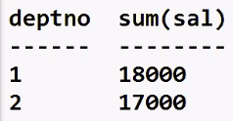

* Select sum(sal) from emp

Group by deptno;

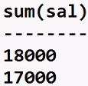

* Select sum(sal) sum_sal from emp

Group by deptno;

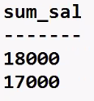

* Select max(sum_sal) from

(select sum(sal) sum_sal from emp

Group by deptno) abcd;

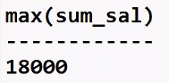

* Select deptno, sum(sal) from emp

Group by deptno

Having sum(sal) =

(select max(sum_sal) from

(select sum(sal) sum_sal from emp

Group by deptno) abcd);

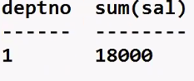

* Select dname , sum(sal) from emp, dept

Where dept.deptno = emp.deptno

Group by dname

Having sum(sal) =

(select max(sum_sal) from

(select sum(sal) sum_sal from emp

Group by deptno) abcd);

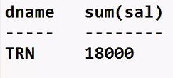

* INLINE VIEW 🡪 if you have a sub-query in the FROM clause , then its known as Inline View
* **Correlated Sub- query (using the EXISTS operator) :-**
* This is the exception when sub-query is faster than join
* If you have a join alongwith DISTINCT , to make it work faster use Correlated sub-query (use the EXISTS operator)

Display the DNAMEs that contain employees :-

Solution #1-

* Select deptno from emp;

1

1

1

2

2

* Select distinct deptno from emp;

1

2

* Select dname from dept

Where deptno = any (1,2)

(select distinct deptno from emp);

TRN

EXP

* Select dname from dept

Where deptno in (1, 2)

(select distinct deptno from emp)

TRN

EXP

* Select dname from dept

Where deptno not in (1, 2)

(select distinct deptno from emp)

MKTG

Solution #2 :-

* Select dname from emp, dept

Where dept.deptno = emp.deptno;

TRN  
TRN  
TRN  
EXP  
EXP

* Select distinct dname from emp, dept

Where dept.deptno = emp.deptno;

TRN  
EXP

Solution #3 :-

* Select dname from dept where exists

(select deptno from emp

Where dept.deptno = emp.deptno);

TRN   
EXP

* First the main query is executed
* For every row returned by main query, it will run the sub query once
* Sub- query returns Boolean TRUE value or FALSE value
* If sub-query returns TRUE value, then main query is eventually executed for that row
* If sub-query returns FALSE value, then main query is not executed for that row
* Unlike earlier , we do not use DISTINCT here , therefore no sorting takes place in SERVER RAM ; this speeds it up
* Unlike a Join, the number of full table scans is reduce; this further speeds it up
* Select dname from dept where not exists

(select deptno from emp

Where dept.deptno = emp.deptno);

MKTG

15-10-24

MYSQL – SQL – SET OPERATORS

* Foundation of RDBMS is based on set theory
* Founder of RDBMS 🡪 Dr. E. F. Codd (1968)

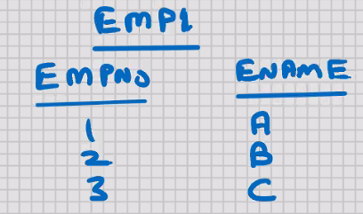 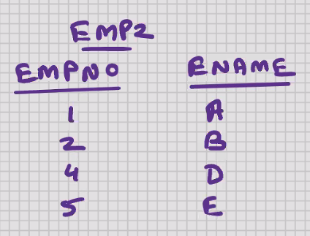

* Select empno1, ename from emp1

**union**

Select empno2, ename from emp2;

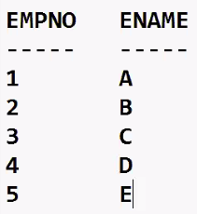

* Structure of both the select statements has to be the same
* Number of columns in both and the corresponding datatypes have to match
* the columns name may be different

Union 🡪 will combine the output of both the SELECT statements and it will suppress the duplicates.

* Select empno1, ename from emp1

**Union all**

Select empno2, ename from emp2

Order by 1;

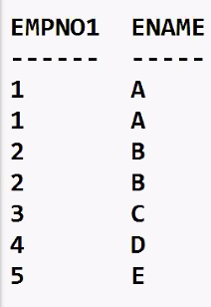

* Union all will combine the output of both the SELECT statements and the duplicates are not suppressed
* Select empno1, ename from emp1

**intersect**

Select empno2, ename from emp2

Order by 1;

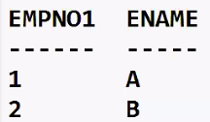

* Intersect will return what is common in both the SELECT statements and the duplicates are suppressed
* Select empno1, ename from emp1

**except**

Select empno2, ename from emp2

Order by 1;

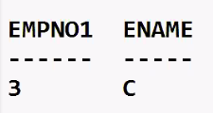

* Except will return what is present in the first SELECT statement and not present in the second SELECT statement and the duplicates are suppressed

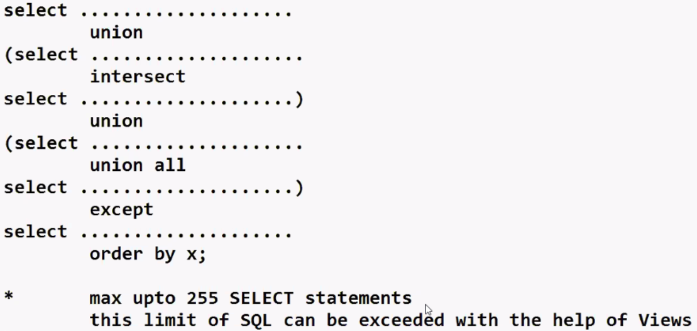

* Select job from emp where deptno = 10

Intersect

Select job from emp where deptno = 20;



* Select job from emp where deptno = 10

Except

Select job from emp where deptno = 20;

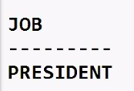

MYSQL - pseudocolumns

* Fake columns (virtual columns)
* Its not a column of the table, but you can use it in SELECT statement
* E.g. :-

1. Computed columns (ANNUAL = sal*12)
2. Expressions (NET_EARNINGS = sal+comm-tax)
3. Function- based column(AVG_SAL = avg(sal), R_SAL = round(sal, -3))

* RDBMS supplied pseudocolumns :-

ROWID 🡪

* ROWID stands for row identifier
* ROWID is not a column of the table, but you can use it in SELECT statement
* ROWID is the row address
* ROWID is the actual physical memory location in the DB server HD where that row is located
* ROWID is a fixed- length encrypted string of 18 characters
* When you SELECT from a table, the order of rows in the output depends on the row address; it will always be in the ascending order of ROWID
* When you INSERT a row, the address (Rowid) is constant for the life of the row
* When you UPDATE a row, if the row length is decreasing, then the address (Rowid) is will not change
* When you UPDATE a row, if the row length is increasing, and if free space is not available, then the address (Rowid) will change
* No two rows of any table in the entire DB Server HD can have the same Rowid
* Rowid works as an unique identifier for every row in the database
* Rowid is used by MySQL to distinguish between two rows in the DB server HD
* The practical use of ROWID is :-
* You can use ROWID to UPDATE or DELETE the duplicate rows
* ROWID is used internally by MySQL :-
* Row locking
* To manage the indexes
* To manage the cursors
* To distinguish between two rows
* Row management

Etc.



🡪select rowid , ename, sal from emp;

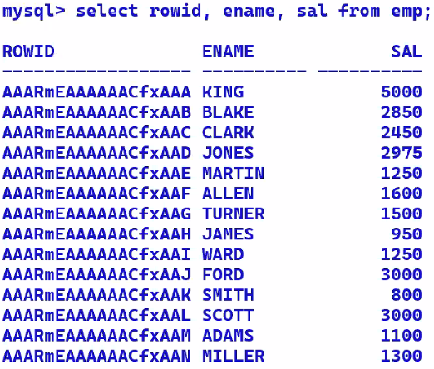

MYSQL – INDEXES



* Indexes are present in all RDBMS, all DBMS, and some of the programming languages also
* To speed up the searching operations (for faster access)
* To speed up the SELECT statement with a WHERE clause
* indexes are automatically invoked by MySQL as and when required
* indexes are automatically updated by MySQL for all the DML operations
* duplicate values are stored in index
* null values are not stored in an index
* no upper limit on the number of indexes per table
* larger the number of indexes, the slower would be the DML operations
* cannot index TEXT and BLOB columns
* if you have multiple INDEPENDENT columns in the WHERE clause, then you should create separate indexes for each column, MySQL will use the necessary indexes as and when required

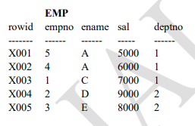

* Select * from emp where empno = 1;

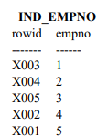

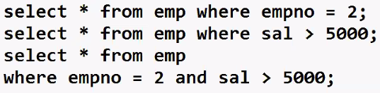

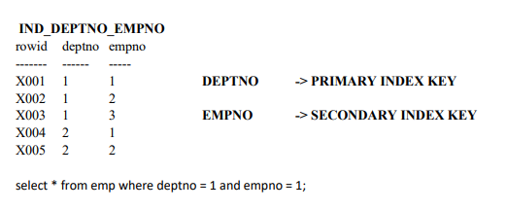



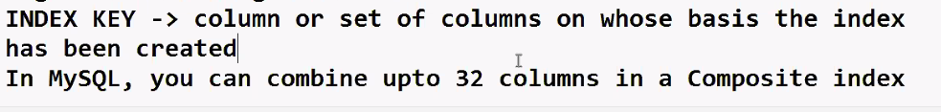

Conditions when an index should be created :-

* To speed up the select statement with a WHERE clause
* If SELECT retrieves < 25% of table data
* Primary key and unique columns should always be indexed
* Common columns in join operations should always be indexed

🡪select * from emp where empno = 1;

🡪select * from emp where empno = 5;

🡪select * from emp where empno < 2;

🡪select * from emp where empno > 1; -> MySQL will use the index but it will be very slow

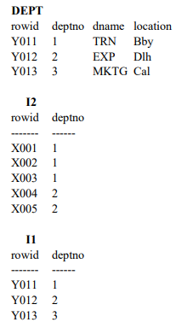

🡪select dname, ename from emp,

dept where dept.deptno = emp.deptno;

Syntax to create INDEX: - (DDL command)

* create index indexname on table(column);
* create index indexname on table(column1,column2); -> composite index
* no upper limit on creating indexes on a table in MySQL and Oracle

**(banake chod deneka RAM bharose)**

* create index i_emp_empno on emp(empno);
* create index i_emp_ename on emp(ename);
* create index i_emp_sal on emp(sal);

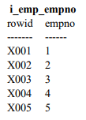

* to see which indexes are created for specific table :-
* show indexes from emp;
* select * from emp where empno = 1; -> Execute very fast **(makkhan ke mafik)**
* create index i_emp_ename on emp(ename);
* create index i_emp_sal on emp(sal);
* create index i_emp_deptno_empno on emp(deptno,empno);
* create index i_emp_empno on emp(empno desc); -> Descending
* create index i_emp_deptno_empno on emp(deptno desc,empno desc);

TO DROP INDEX:-

* drop index i_emp_empno on emp;
* create index i_orders_onum on emp(onum desc); -> latest (new) orders will stored first at the top, older orders would be below

UNIQUE INDEX: -

* create unique index i_emp_empno on emp(empno);

🡪perform one extra function, it wont allow to INSERT/ UPDATE duplicate value in EMPNO

🡪at the time of creating the unique index, if you already have duplicate values in EMPNO, then MySQL will not allow you to create the unique index

* drop index…..;
* drop table emp;
* if you drop the table/column, then associated indexes are dropped automatically
* Oracle & MySQl doesn't allow more than one indexes on same column

Types of Indexes: -

1. Normal index (MySQL)

2. Unique index

3. Clustered index

4. Bitmap index 3 to 6 Advanced (Oracle)

5. Index-Organized table

6. Index partitioning

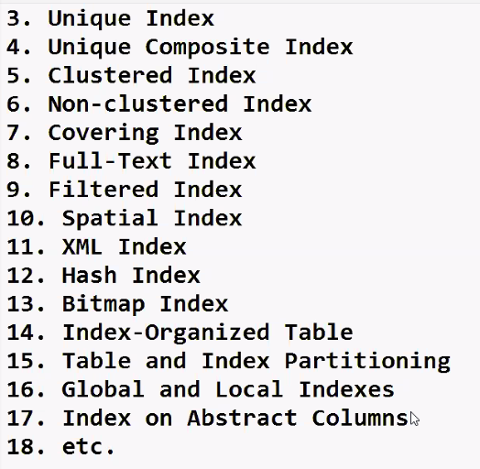

16-10-24

**MYSQL – SQL – ALTER TABLE**

ALTER table is a DDL command

* Rename a table
* Add a column to the table
* Drop a column
* Increase width of column

🡪Indirectly :-

* Reduce width of column
* Change the datatype
* Copy the rows from one table into another table
* Copy a table (for testing purposes)
* Copy ONLY the structure of the table
* Rename a column
* Change position of columns in table structure(because of null values, for storage considerations)
* MYSQL ENTERPRISE BACKUP (Export and Import)

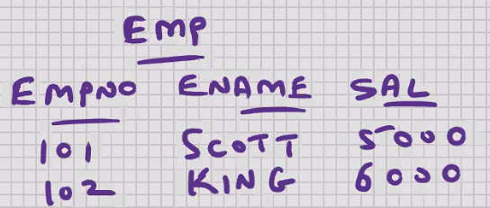 

* Select count(*)-count(empno), count(*)-count(ename), coumt(*)-count(sal) from emp;
* Select * from emp; 🡨 not recommended
* Select empno, ename, sal from emp; 🡨 recommended
* Insert into emp values(.........); 🡨 Recommended
* Insert into emp(empno, ename, sal) values(.........); 🡨 recommended
* Rename a column
* Rename table emp to employees;
* Rename is a DDL command (extra command in mysql)
* Add a column to the table
* Alter table emp add gst float;
* Drop a column
* Alter table emp drop column gst;
* If you drop a column , then indexes on that column are dropped automatically
* Increase the width of column
* Alter table emp modify ename varchar(30);
* Reduce the width of column
* In mysql :-

🡪 Alter table emp modify ename varchar(20);

* Data will be truncated
* In oracle :-

🡪 Alter table emp modify ename varchar(20); 🡨 error

* In oracle, You can reduce the width provided the contents are null
* Alter table emp add x varchar(25);
* Update emp set x = ename, ename = null;
* Alter table emp modify ename varchar(20);

/* data testing with x column; check that none of the names > 20 chars */

* Update emp set ename = x;
* Alter table emp drop column x;
* Its recommended you use above solution for mysql

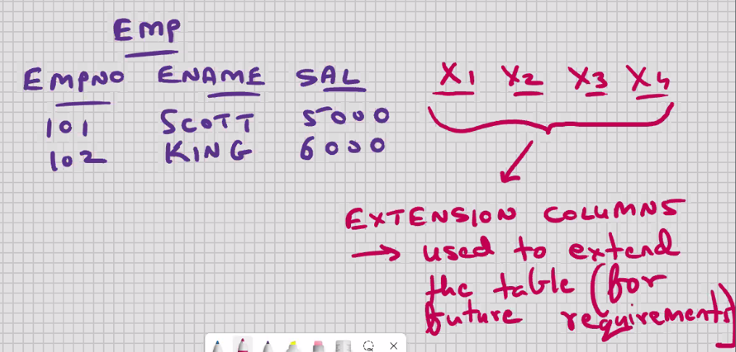

* Change the datatype
* Alter table emp modify empno char(20);
* Copy the rows from one table into another table
* Insert into emp_kh

select * from emp_jh;

* The above command will work provided the structure of both the tables is the same.

--- to copy specific rows ONLY :-

* Insert into emp_kh

Select* from emp_jh where ...................;

E.g.

🡪insert into emp_kh

Select empno, ename, sal from emp_jh where deptno = 1;

* Copy a table (for testing purpose)
* Create table emp2

As

Select * from emp;

1. It will create table emp2 as per structure of SELECT statement
2. SELECT statement will be executed

* When you CREATE TABLE using sub-query, indexes on original table are not copied into the new table
* If you want indexes on the new table, you will have to create them manually
* To copy specific rows/columns ONLY :-

🡪Create table emp2

As

Select empn, ename from emp where ..............;

* Copy ONLY the structure of table
* Solution 1 :-

🡪create table emp2

As

Select * from emp2;

Delete form emp2;

Commit;

* Solution 2 :-

🡪create table emp2

As

Select * from empl

Truncate table emp2;

* Solution 3:-

🡪create table emp2

As

Select * from emp where 1 = 2; //impossible where condition

* Truncate is a DDL command
* Truncate will delete all the rows and commit

|  |  |
| --- | --- |
| **DELETE** | **TRUNCATE** |
| Common for all RDBMS | Extra command in mysql and oracle |
| ANSI sql (ANSI stds and ISO stds) | Not ANSI sql (MYSQL stds and Oracle stds) |
| DML command | DDL command |
| Requires commit | Auto commit |
| Rollback is possible | Rollback is not possible |
| WHERE clause is supported;  Can DELETE specific rows only | Where clause is not supported;  TRUNCATE will DELETE ALL the rows and COMMIT |
| DELETE triggers on table will execute | DELETE triggers on table will not execute |

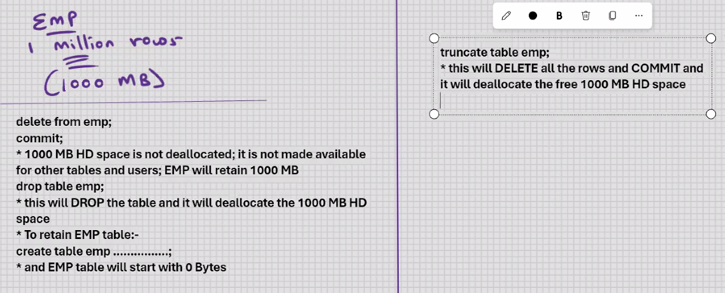

* Rename a column
* Create table emp2

As

Select empno , ename , sal salary

From emp;

Drop table emp;

Rename table emp2 to emp;

* Change the position of columns in table structure (because of null values, for storage considerations)
* Create table emp2

As

Select ename , sal , empno from emp;

Drop table emp;

Rename table emp2 to emp;

**MYSQL – SQL – CONSTRAINTS**

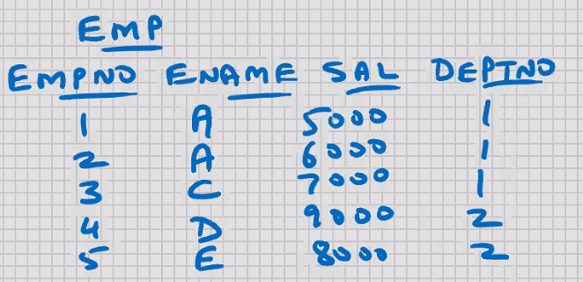

* The limitations/restrictions imposed on a table
* PRIMARY KEY
* Key is another word for column
* Primary column
* Column or set od columns that uniquely identifies a row
* In our example we can consider EMPNO as primary key
* Duplicate values are not allowed; it has to be unique
* Also, null values are not allowed; this is a mandatory column
* It’s recommended that every table should have a primary key; it helps from a long-term perspective
* Purpose of primary key is row uniqueness; with the help of primary key column, you can distinguish between 2 rows of a table
* Text and blob cannot be primary key
* Unique index is automatically created for primary key column (because primary key is the best column for searching)
* YOU CAN HAVE ONLY 1 PRIMARY KEY PER TABLE
* COMPOSITE PRIMARY KEY 🡪 combine 2 or more columns together to serve the purpose of primary key; preferably they should be interdependent columns
* In MySQL, you can combine upto 32 columns in a COMPOSITE PRIMARY KEY
* If you have a composite primary key, then a composite unique index is automatically created
* CANDIDATE KEY 🡪 is not a constraint
* CANDIDATE KEY 🡪 is a definition
* CANDIDATE KEY 🡪 is a column that is primary key in waiting
* CANDIDATE KEY 🡪 besides the primary key, any other column in the table that could serve the purpose of primary key, is a good candidate for primary key, is known as Candidate key.
* Steps for identifying primary key :-

1. Identify some key column and make it the primary key of your table
2. If you cannot identify some key column, then try to implement composite primary key
3. If this is not possible, then you add an extra column to the table to serve the purpose of primary key

* SURROGATE KEY :-

1. Is not a constraint
2. Is a definition
3. When an extra column to the table to serve the purpose of primary key, then such a primary key is known as surrogate key

* Primary key is the best column for searching, and with CHAR datatype the searching and retrieval is very fast; therefore for surrogate key the CHAR datatype is recommended
* Creating primary key:-
* Create table emp // creating primary key

(

Empno char(4) primary key,

Ename varchar(25),

Sal float,

Deptno int

);

* Insert into emp values(‘5’, ‘F’ , 5000, 2); 🡨 error
* Insert into emp values(null, ‘F’ , 5000, 2); 🡨 error
* All constraints are at server level; you can perform the DML operations using MySQL command line client, or MySQL workbench, or Java, or MS .Net, etc,. Or any other front-end s/w, the constraints will always be valid (this feature is known as DATA INTEGRITY)

To view all constraints :-

* Select * from information_schema.table_constraints;

To view particular constraints :-

* Select * from information_schema.table_constraints

Where table_schema = ‘cdacmumbai’;

To view constraint in a particular table :-

* Select * from information_schema.key_column_usage

Where table_name = ‘emp;’

* Unique index automatically created
* Show indexes from emp;
* To drop the primary key constraint :-
* Alter table emp drop primary key;
* To add primary key to an existing table :-
* alter table emp add primary key(empno);
* to change the primary key column :-

DROP the existing primary key constraint and alter table and then we can add new primary key constraint

* Creating composite primary key :-

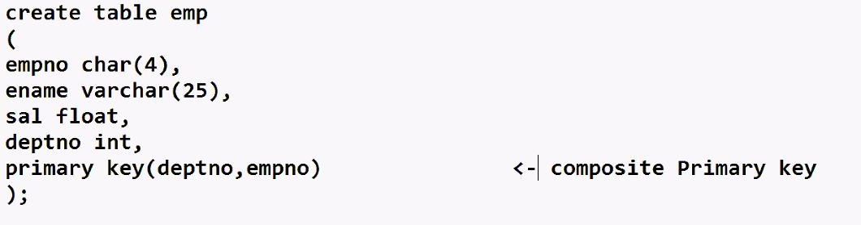

* Show indexes from emp;
* Alter table emp drop primary key;
* Alter table emp add primary key(deptno, empno);
* Constraints are of two types :-

1. Column level constraint

* Constraint specified on one column

1. Table level constraint

* Composite
* Constraint specified on combination of 2 or more columns
* has to be specified at the end of the table structure
* NOT NULL CONSTRAINT :-
* Null values are not allowed
* Duplicate values are allowed
* Always a column level constraint

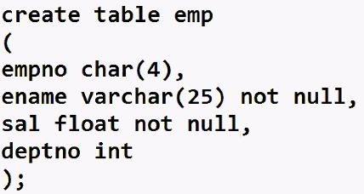

Questions 🡺

1. Difference between primary key and not null
2. Similarity between primary key and not null

* Datatype is also a type of constraint
* There are 3 types of integrity :-
* Entity integrity – Primary key
* Referential integrity – foreign key
* Domain integrity – datatype, e.g. int, char(10), etc
* In MySQL, nullability is a part of the database
* To see the not null columns :-

desc emp;

* To drop the not null constraint :-
* Alter table emp modify ename varchar(25) null;
* To add the not null constraint to existing table :-
* Alter table emp modify ename varchar(25) not null;
* Unique constraints :-
* Duplicate values are not allowed
* Null values are allowed
* Can INSERT any number of null values, but no duplicate values
* Unique index automatically created
* Text and blob cannot be unique
* In MySQL, you can combine upto 32 columns in a composite unique.
* YOU CAN HAVE ANY NUMBER OF UNIQUE CONSTRAINTS PER TABLE, UNLIKE PRIMARY KEY

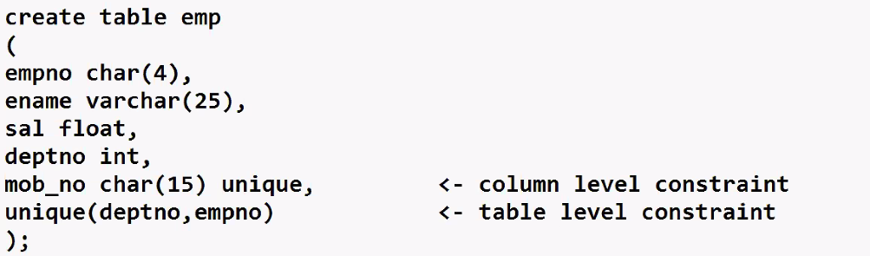

* Select * from information_schema.table_constraints;
* Select * from information_schema.table_constraints

Where table_schema = ‘cdacmumbai’;

* Select * from information_schema.key_column_usage

Where table_name = ‘emp’;

* Unique constraint is also an index
* To drop it :-

🡪drop index mob_no on emp;

🡪drop index deptno on emp;

* To add unique constraint to an existing table :-

🡪alter table emp add constraint u_emp_mob_no unique(mob_no);

Constraint u_emp_mob_no 🡪 constraint constraintname

Constraint u_emp_mob_no 🡪 optional

* column level constraint can be specified at table level(end of structure), but a table level composite constraint can never be specified at column level
* most developers prefer this, it make the CREATE table command more readable
* column level constraint can be specified at table level (end of structure), except for the not null constraint which is always a column level constraint and therefore the syntax will not support you from specifying it at table level
* 1 column can have more than 1 constraint

e.g.

primary key and forign key

not null and unique

etc.

* Solution for candidate key :-

Not null constraint + unique index

OR

Not null constraint + unique constraint

* With the help of above logic, indirectly you can have multiple primary keys in the table; one directly, the remaining indirectly.

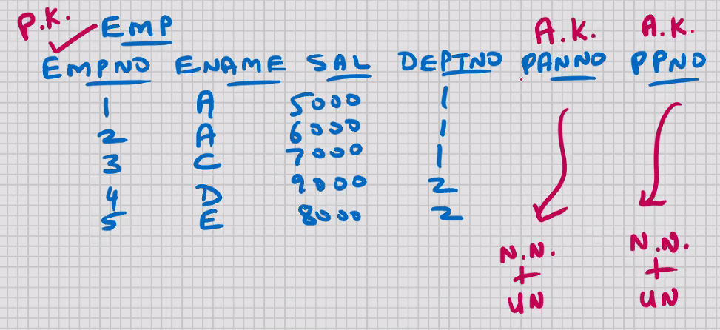

* Alternate key :-

1. Is not a constraint
2. Is a definition
3. For the candidate key column, if you give it a not null constraint + unique index/constraint, then it becomes an alternative to primary key, then such a candidate key column is known as Alternate key.

* Super key :-

1. Is not a constraint
2. Is a definition
3. If you have 1 or more alternate keys in the table, then the primary key is also known as super key

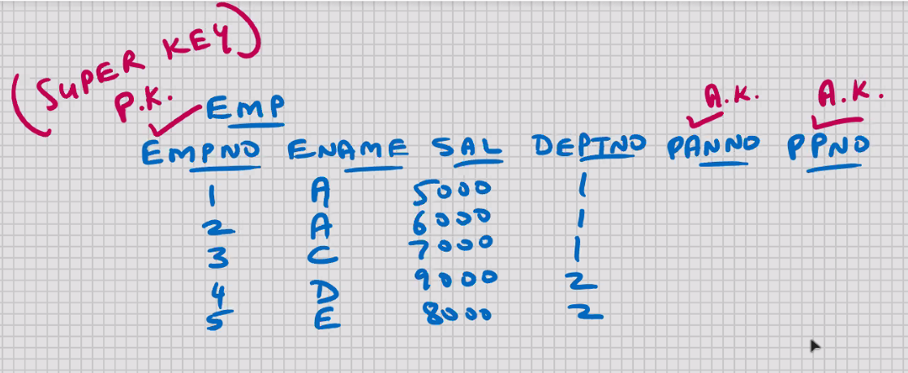

* FOREIGN KEY :-
* Foreign column (column that is coming/derived from elsewhere)
* Column or set of columns that references a column or set of columns of some table
* Foreign key constraint is specified on the child column (not the parent column)
* Parent column has to be primary key or unique (this is a pre-requisite for foreign key)
* Foreign key will allow duplicate values
* Foreign key will allow null values also
* Foreign key may reference column of same table also (self - referencing) (parent column and child column both are present in the same table)

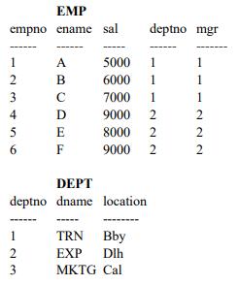

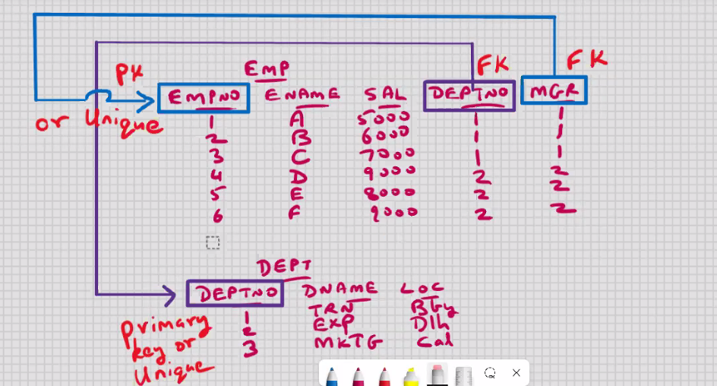

* Create table dept

(

Deptno int primary key,

Dname varchar(15),

Loc varchar(10)

);

* Create table emp

(

Empno char(4) primary key,

Ename varchar(25),

Sal float,

Deptno int,

Mgr char(4),

Constraint fk_emp_deptno foreign key(deptno)

References dept(deptno)***on delete cascade on update cascade***,

Constraint fk_emp_mgr foreign key(mgr)

References emp(empno)

);

constraint fk_emp_deptno -> optional

constraint fk_emp_mgr -> optional

🡪 select * from information_schema.table_constraints;

🡪 select * from information_schema.table_constraints

Where table_schema = ‘cdacmumbai’;

🡪 select * from information_schema.key_column_usage

Where table_name = ‘emp’;

If you want to drop the constraint :-

* Alter table emp drop foreign key fk_emp_deptno;
* Alter table emp add foreign key(deptno) references dept(deptno);

To disable the foreign key constraint :-

For current connections :-

* set foreign_key_checks = 0;
* set foreign_key_checks = 1;

For all connections :-

* set global foreign_key_checks = 0;
* set global foreign_key_checks = 1;
* you cannot delete the parent row when child row exists
* delete from dept where deptno = 2;
* on delete cascade 🡪 if you delete the parent row, then mysql will automatically delete the child rows also
* if you want to retain the child row :-
* update emp set deptno = null where deptno = 2;
* on update cascade 🡪 if you UPDATE the parent column, then MySQL will automatically update the child rows also
* update dept set deptno = 4 where deptno = 2;

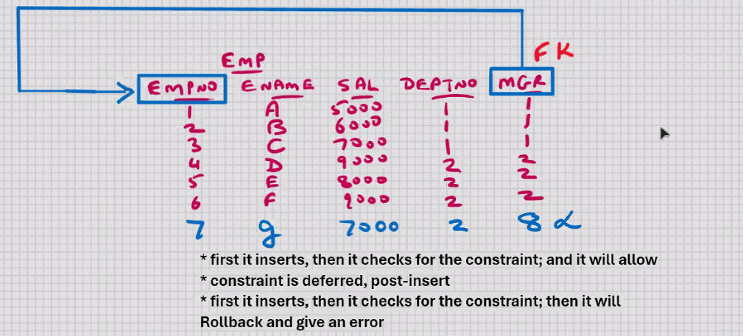

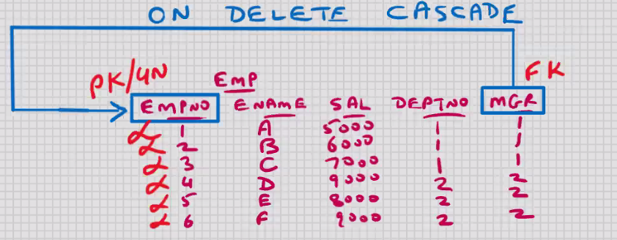

* delete from emp where empno = 1; // in above case all rows will be deleted
* avoid on delete cascade in the event of self referencing; you may delete more rows than expected

17-10-24

* CHECK :-
* Used for validations (used for checking purposes)
* E.g. sal < 10000, age > 25
* Create table emp

(

Empno int auto_increment primary key,,

Ename varchar(25) check(ename = upper(ename)),

Sal float default 7000

Check (sal between 5001 and 2999999), 🡨 column level

Deptno int reference dept (deptno),

Status char(1) default ‘T’

Check (status in (‘T’,’P’,’R’)), 🡨column level

Comm float not null,

mob_no char(15) unique,

check(sal+comm < 5000000) 🡨table level

);

* DEFAULT is not a constraint
* DEFAULT is clause that you can use with CREATE TABLE
* If you enter some value, then it will take that value; if nothing is specified, then it will take default value

To make use of DEFAULT value and AUTO_INCREMENT, use the following INSERT statement :-

* Insert into emp(ename, deptno, comm, mob_no)

Values(.............................................);

* AUTO_INCREMENT 🡪 by default it starts from 1 , by default it increments by 1

Constraints we can use in check :-

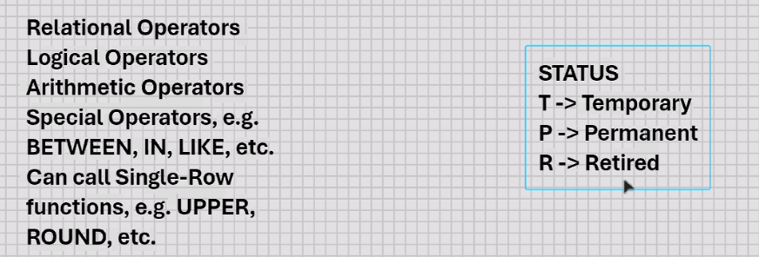

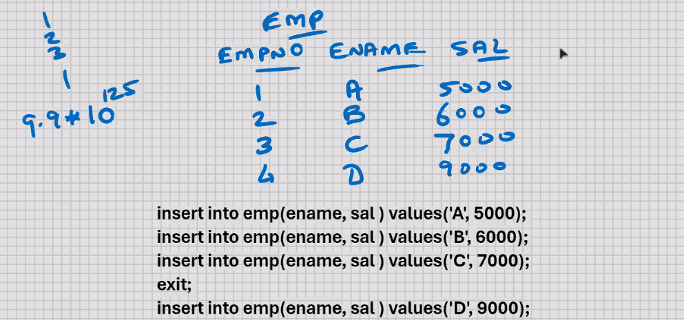

* Rollback and commit have no effect on auto_increment (it has been designed in this manner on purpose keeping in view a multi-user environment )

To avoid the problem of missing numbers :-

* Do not issue the INSERT statements to the database at the time of data entry; when does the data entry, you store the rows in an array; when user issues a commit, you issue the INSERT statements to the database followed by COMMIT

MYSQL – SQL – PRIVILEGES

Grant and Revoke (DCL)

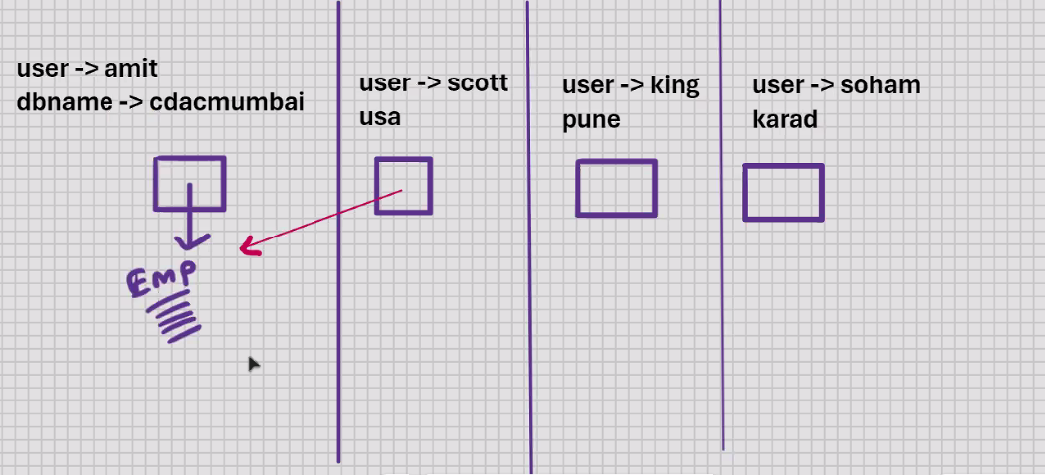

root_mysql > grant select on cdacmumbai.emp to scott@localhost;

root_mysql > grant insert on cdacmumbai.emp to scott@localhost;

root_mysql > grant update on cdacmumbai.emp to scott@localhost;

root_mysql > grant delete on cdacmumbai.emp to scott@localhost;

root_mysql > grant select, insert on cdacmumbai.emp to scott@localhost;

root_mysql > grant all privileges on cdacmumbai.emp to scott@localhost;

root_mysql > grant select on cdacmumbai.emp to scott@localhost, king@localhost;

root_mysql > grant select on cdacmumbai.emp to public;

root_mysql > revoke select on cdacmumbai.emp from scott@localhost;

root_mysql > revoke select on cdacmumbai.emp from public;

select * from information_schema.table_privileges;

cdacmumbai.emp 🡪 dbname.tablename

cdacmumbai.emp 🡪 schemaname.tablename

* SCHEMA IS A SYNONYM FOR A DATABASE

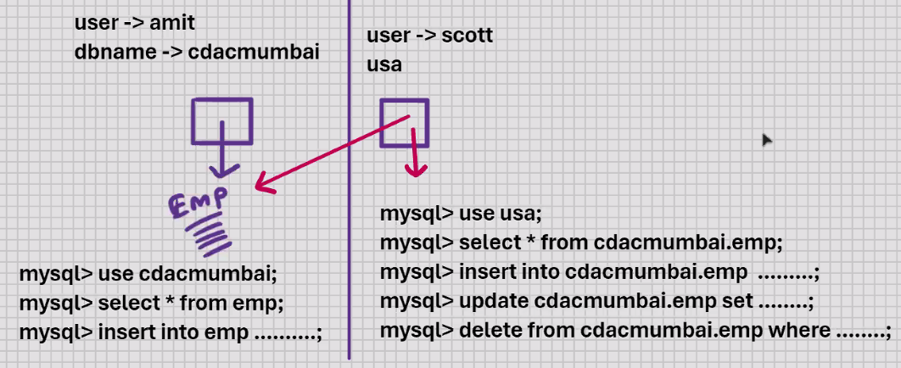

MYSQL – System tables

* Mysql created
* Automatically created when you install mysql
* 78 system tables in Mysql v9
* Set of system tables is also known as DATABASE CATALOG
* Set of system tables is also known as DATA DICTIONARY
* Stored in information_schema
* System tables store complete information about the database
* E.g. statistics (for indexes) , table_constraints, key_column_usage, table_privileges, etc.
* All the system tables are READ_ONLY
* DDL for USER is DML for system tables

Login as root user :-

Mysql> use unformation_schema;

Mysql> show tables;

DATA is of 2 types :-

1. User data

* User created
* User tables and indexes

1. System data (Meta data)

* MySQL created
* Data is stored in system tables
* Also known as Metadata (data about data)

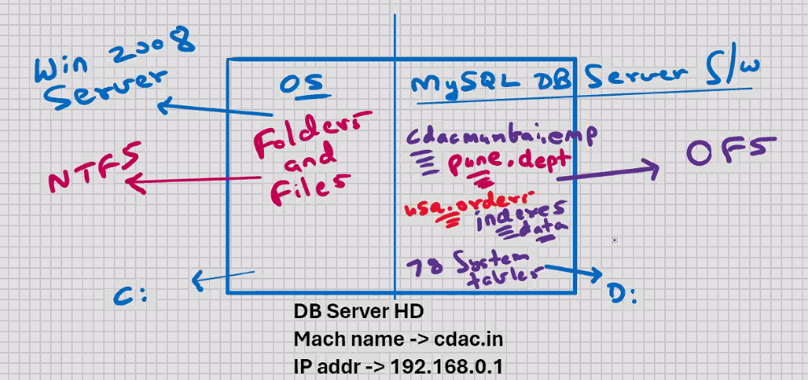

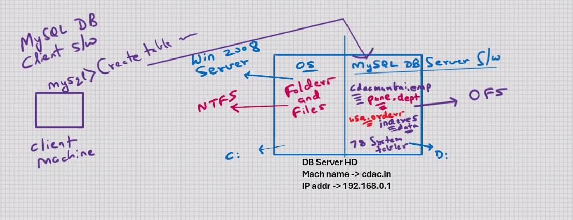

MYSQL DB SERVER S/W is based on linux kernel